Willow Primary Academy
Art and Design Curriculum
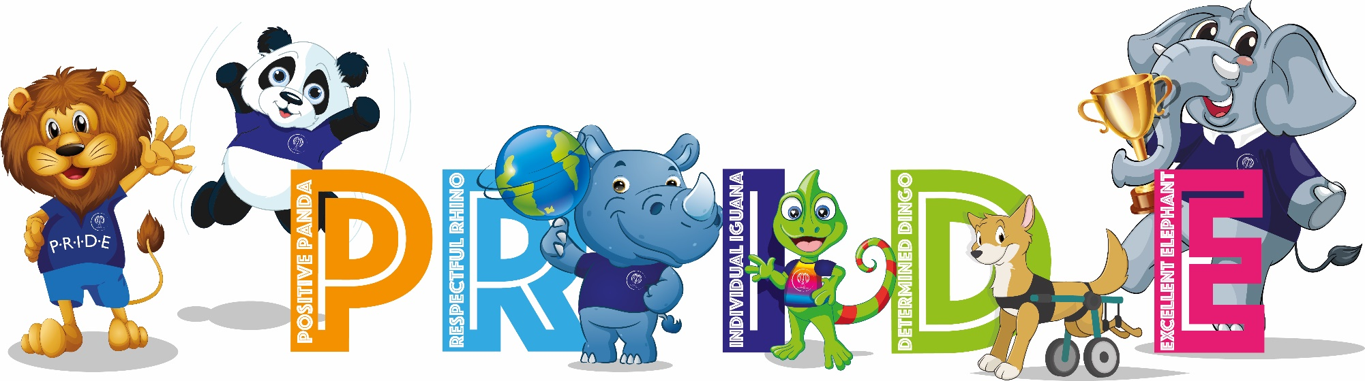
“Every child is an artist” – Pablo Picasso

INTENT
At Willow Primary Academy, we recognise that Art and Design stimulates creativity and imagination and aim to produce life-long artists. Our curriculum provides visual, tactile and sensory experiences and a special way of understanding and responding to the world. It enables children of all abilities to communicate what they see, feel and think through the use of colour, texture, form, pattern and different materials and processes. We encourage children to explore ideas and meanings through the work of a range of artists and designers. The art and design units promote experimentation, invention and creativity. Through learning about the roles and functions of art, they can explore the impact it has had on contemporary life. They explore art from different times and cultures. Pupils also learn about influential people who have affected the art and design world. These may be architects, artists or designers. By learning about these people, we aim to inspire pupils. As a result, we encourage pupils to express themselves and understand how art is applied to the real world.

IMPLEMENTATION
Delivery
- Teachers plan effectively using the Cornerstones Curriculum Maestro.
- Teachers map out learning using the planning tool.
- Four core elements that make up the teaching and learning approach:
      - Engage
      - Develop
      - Innovate
      - Express
- Throughout the art and design scheme, there is complete coverage of all national curriculum programmes of study.
- Unit outcomes and suggested content enable good planning, progression and consistency across the school.
- Key questions are used to open up the content to be studied.
- Assessment takes place during learning to address misconceptions, identify strengths and gaps and inform next steps.
- Cross-curricular links are used whenever possible, i.e., Literacy and Computing.
- Art specific displays are put up in each class that showcase children’s work.

Progression
- The Art curriculum is designed to progressively develop the children’s skills in Art from Reception through to year 6.
- Each project builds on prior learning across key strands, including EYFS, to ensure better cognition and retention.
- Each project has a clear overview outlining key concepts, knowledge, skills and vocabulary to be taught and evaluated to measure impact.
- Adaptive teaching is used to enable every pupil to meet the learning objective.
- The art and design projects are well sequenced to provide a coherent subject scheme that develops children’s skills and knowledge of visual elements, art forms, artists and art movements.
- Projects are placed alongside other subject projects where there are opportunities for making meaningful connections. For example, Beautiful Botanicals has been placed in the same teaching sequence as the science project Plant Nutrition and Reproduction.
- Where possible, projects with similar materials are spaced out to have as little strain on resources as possible. For example, in Key Stage 1, clay work is taught in different terms.
- Seasons are also a consideration for the placement of art and design projects. For example, if children are required to work outdoors, these projects have been placed in either the latter part of the spring or summer term.
- In EYFS, children have a number of opportunities to explore a variety of materials, tools and techniques, experimenting with colour, design, texture, form and function. They regularly share their creations, explaining the processes they’ve used. They being to explore artwork by great artists, such as Matisse and Monet.
- In Key Stage 1, each autumn term begins with the colour project Mix It. The teaching of this project in Years 1 and 2 enables children to be introduced to and then revisit colour theory and provides plentiful opportunities for children to explore primary and secondary colours. Year 1 begins by exploring themes directly related to the children themselves, such as their facial features, the surrounding natural world and their local community. In Year 2, the projects expand children’s artistic horizons to study a more comprehensive range of artists, artistic movements and creative techniques.
- In Lower Key Stage 2, each autumn term begins with the colour project Contrast and Complement. In Years 3 and 4, the teaching of this project enables children to build on their previous understanding of colour and further develop their expertise by studying theory. In Year 3, children expand their experiences to study a broader range of art forms, artists and genres. They also begin to study art from specific and diverse periods of history. Other genres studied in Year 3 build on previous techniques learned in Key Stage 1 and include more complex techniques in printmaking, drawing, painting and textiles. In Year 4, children develop more specialised techniques in different art forms. They explore ways in which cultures have influenced art and crafts by studying, for example, medieval weaving techniques and the religious significance of Islamic art.
- In Upper Key Stage 2, each autumn term begins with the colour project Tints, Tones and Shades. Teaching these projects in Years 5 and 6 enables children to build on their previous understanding of colour theory and develop further expertise with colour by studying tonal variations and more complex colour charts. In Year 5, children develop and combine more complex artistic techniques in a range of genres. Children continue to build on their understanding of other historical periods and cultures by studying the ancient Chinese art form of taotie and the significance of the Expressionist movement. In Year 6, children are encouraged to work more independently in projects like Environmental Artists and Distortion and Abstraction. Such projects require them to consider more conceptual representations of personal, environmental, social or political messaging. Children also explore diversity in art.

IMPACT
The structure of the art curriculum ensures that children are able to develop their knowledge and understanding of the work of artists, craftspeople and designers from a range of times and cultures and apply this knowledge to their own work. The consistent use of children’s sketchbooks means that children are able to review, modify and develop their initial ideas in order to achieve high quality outcomes. Children learn to understand and apply the key principles of art: line, tone, texture, shape, form, space, pattern, colour, contrast, composition, proportion and perspective. The opportunity for children to refine and develop their techniques over time is supported by effective lesson sequencing and progression between year groups. The impact of our art and design curriculum can be seen not only in our children’s sketch books but also through classroom displays and the school environment. By the end of each Key Stage, all children can apply and understand the skills, knowledge and processes they have been taught so that they are proficient in drawing, painting, sculpture and other art, craft, and design techniques.

Long Term Plan – 2022 – 23
 | Term 1 |  | Term 2 |  | Term 3
FS | Evident in all projects and through enhanced provision
Year 1 | Mix it | Funny faces and fabulous features | Rain and sunrays - printing |  | Street view – 3D mural
Year 2 | Mix it | Still life | Flower Head – drawing, printing, 3D forms |  | Portraits and poses
Year 3 | Contrast and complement | Prehistoric Pots - clay | Ammonite – Sketching, printing, sculpture | People and places - Landscapes | Beautiful botanicals- Weaving, printing, painting | Mosaic masters
Year 4 | Contrast and complement | Warp and Weft - Weaving | Statues, Statuettes and Figurines | Islamic Art – Fabric and clay | Vista – Landscape and perspective | Animals – sketching, printing, clay
Year 5 | Tints, Tones and Shades | Taotie – Casting, watercolour | Light, Line and Shadow | Nature's Art – Sculpture and sketch | Mixed Media – collage, photo collage | Expression - portraits
Year 6 | Tints, Tones and Shades | Trailblazers, Barrier Breakers | Inuit – Printing, carving | Environmental Artists | Distortion and Abstraction – abstract painting | Bees, Beetles and Butterflies – sketching, collage, Pop Art

