Willow Primary Academy
History Curriculum
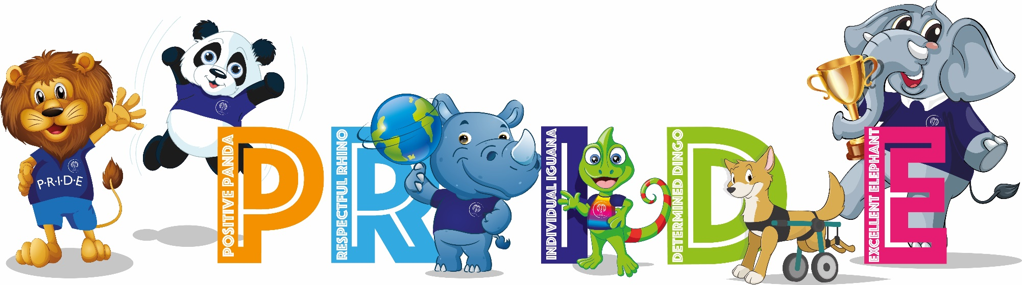
“Study the past if you would define the future.” – Confucius

INTENT
At Willow Primary Academy our history curriculum will allow our children to gain a coherent knowledge and understanding of Britain’s past and that of the wider world. The curriculum is designed so that children gain this knowledge as they progress through the school. We also recognise the important role History plays in preparing our children with the skills that they need for life including: raising their aspirations; understanding how to be good and responsible citizens, understanding change and societal development and a context in which to understand themselves and others. It is vital that our children have access to the much wider world than their local community. We strive to inspire pupils’ curiosity about the past and to know more about the past. Our curriculum provides children with opportunities to ask perceptive questions, think critically, weigh evidence, sift arguments, and develop perspective and judgement. Through the teaching of History, we endeavour to teach children to understand the complexity of people’s lives, the process of change, the diversity of societies and relationship between different groups, as we as their own identify and the challenges of their time. At Willow, teaching history is a way to broaden our pupils’ horizons, challenge any preconceived ideas and develop their life skills in order to prepare them for secondary school and beyond.

IMPLEMENTATION
Delivery
- Teachers plan effectively using the Cornerstones Curriculum Maestro.
- Teachers map out learning using the planning tool.
- Four core elements that make up the teaching and learning approach:
      - Engage
      - Develop
      - Innovate
      - Express
- The choice of historical periods follows the guidance set out in the national curriculum, with specific details relating to significant events and individuals chosen to present a rich and diverse account of British and world history.
- Unit outcomes and suggested content enable good planning, progression and consistency across the school.
- Key questions are used to open up the content to be studied.
- Assessment takes place during learning to address misconceptions, identify strengths and gaps and inform next steps.
- Cross-curricular links are used whenever possible, i.e. Literacy and Computing.
- History specific displays may be put up in each class that showcase children’s work.

Progression
- The History curriculum is designed to progressively develop the children’s skills in History from Reception through to year 6.
- History is taught in driver projects that enable pupils to study in depth.
- The choice of historical periods follows the guidance set out in the national curriculum, with specific details relating to significant events and individuals chosen to present a rich and diverse account of British and world history.
- Each project builds on prior learning across key strands, including EYFS, to ensure better cognition and retention.
- Each project has a clear overview outlining key concepts, knowledge, skills and vocabulary to be taught and evaluated to measure impact.
- Adaptive teaching is used to enable every pupil to meet the learning objective, e.g. adult support, scaffolding, peer work.
- Opportunities are made for making meaningful connections with other projects, history projects are sequenced accordingly, e.g. the project Dynamic Dynasties is taught alongside the art and design project Taotie to give children a better all-round understanding of ancient Chinese arts and culture.
- In EYFS, children have a number of opportunities to order events in chronological order by using stories and their own experiences. Children explore and discuss similarities and difference between things in the past and now, drawing on their own experiences and what has been studied in class.
- In Year 1, children begin by studying the project Childhood. This project builds on children’s past experiences, including their family history and events within living memory, and works well as an introductory project. In the summer term, children learn the history of their school and compare schooling in the Victorian period.
- In Year 2, children extend their studies to explore a broader range of periods. They explore the concept of significance and the significant people that have greatly influenced history. In the summer term, children are introduced to the challenging concepts of power and monarchy in Britain in preparation for more complex historical topics in Key Stage 2.
- In Year 3, children begin to study ancient history in the project Gods and Mortals. This project enables children to explore life in ancient Greece, including examining the achievements and influence of ancient Greece on the western world. Children then continue to develop their knowledge of the chronology of British history in the project about the Roman Empire, its invasion of Britain and Britain’s ensuing Romanisation.
- By the end of Year 4, children begin study ancient history in the project Ancient Civilisations. This project enables children to learn about the achievements of the earliest civilisations, including ancient Sumer, the Indus Valley civilisation and ancient Egypt.
- In Year 5, children continue to build their knowledge of ancient civilisations with an in-depth analysis of ancient China. Children study the significance and influence of ancient China and its prowess and advancements in the written word, technology and metalwork. Children then further study British History by studying the Tudor dynasty where they learn about Henry VIII and his marriages, life and legacy.
- In the autumn term of Year 6, children study the more complex historical issues of enslavement, colonialism and power in the project Maafa. In this project, children explore a range of African kingdoms, including the Kingdom of Benin, and study Britain’s role in the development, perpetuation and abolition of the slave trade. Children complete their historical studies with the project Britain at War. This project enables children to study the role war has played in Britain’s history since 1066, focusing on the First and Second World Wars as crucial turning points in British history.

IMPACT
At Willow Primary Academy, children are engaged and curious in lessons. They are critical and analytical in their thinking, making informed and balanced judgements based on their knowledge of the past. Children are aware of how historical events have shaped the world today, including History at the local and personal level. They develop enquiry skills to pursue and investigate their own interests within a topic. Pupils at Willow, visit historically relevant sites and museums and learn from visitors to enhance their learning in History and create positive memories. Children retain learning and can make connections between what they have previously learned and what they are currently learning and are able to articulate what they have learned in History and can describe significant periods, events and people from the past.

Long Term Plan – 2022 – 23
 | Term 1 |  | Term 2 |  | Term 3
FS | Me and My Community | Once upon a time | Starry Night | Ready Steady Grow | Animal Safari | On The Beach
Year 1 | Childhood |  |  |  | School Days - Victorians
Year 2 | Movers and Shakers – Significant People |  |  |  | Magnificent Monarchs – British History
Year 3 | Gods and Mortals – Greeks |  |  |  | Emperors and Empires - Romans
Year 4 |  |  | Ancient Civilizations – Egyptians, Sumer, Indus valley
Year 5 | Dynamic Dynasties – Ancient China |  |  |  | Off with her Head! – Tudors inc. Henry VIII
Year 6 | Maafa – Africa past and present, Slave trade |  |  |  | Britain at War – WWI and WWII

