Willow Primary Academy
MfL Curriculum
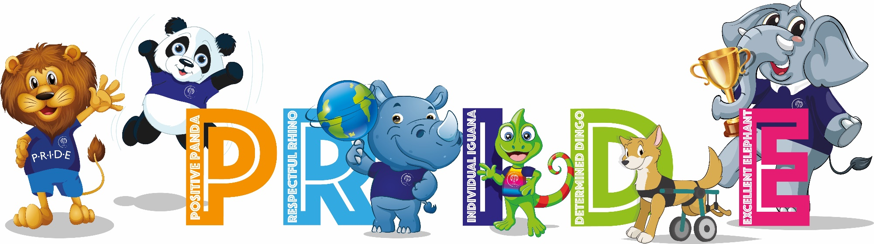
“Without language, one cannot talk to people and understand them; one cannot share their hopes and aspirations, grasp their history, appreciate their poetry or savour their songs” – Nelson Mandela

INTENT
At Willow Primary Academy children in KS2 learn French. We believe a high-quality languages education should foster pupils’ curiosity and deepen their understanding of the world. The teaching enables pupils to express their ideas and thoughts in another language and to understand and respond to its speakers, both in speech and in writing. It also provides opportunities for them to communicate for practical purposes, learn new ways of thinking and read great literature in the original language. The way we teach French provides the foundation for learning further languages, equipping pupils to study and work in other countries. Our children are given the opportunity to be language detectives and regularly practise using their language learning super skills. The children also learn how to use these skills in other languages too.

IMPLEMENTATION
Delivery
- Teachers plan effectively using the Primary Languages Network curriculum.
- Teachers use the planning tool online to timetable and deliver lessons.
- Lessons are delivered using the ‘Video to teach’ videos which provide pedagogical modelling.
- The structure of lessons makes clear links with primary focuses on structure and grammar in English
- Lessons supportive children’s growing knowledge of grammatical structures and terminology
- Lessons are designed to enable the children to apply rules to the new target language successfully
- Lessons are creative and active so that the learning is meaningful and memorable.
- Unit outcomes and suggested content enable good planning and progression.
- Lesson activities can consist of actions, rhymes, stories, song, drama, grammar focus, video clips, air writing, sentence structure, dictionary work, book making and many more creative ways to extend, embed and combine language skills.
- Assessment takes place during learning to address misconceptions, identify strengths and gaps and inform next steps.
- Cross-curricular links are used whenever possible, i.e. Literacy, Science and Computing.

Progression
- Throughout the SOW there are opportunities to introduce and practise appropriate target language vocabulary, to identify and use nouns, adjectives, verbs, prepositions, and conjunctions in the target language, to explore and build a secure understanding of the target language phonics, and to find out more about the culture of the target language countries.
- Progression in vocabulary acquisition, grammar, and phonics, is planned for and built in across the 4 stages.
- Language learning skills and links between languages and literacy are explored age and stage appropriately.
- Within the body of the lessons there are planned for /suggested opportunities to sing, play games, perform, develop extended writing (Rainbow Writing), keep a record, and make links across the curriculum.
- Progression in skills documents enable teachers to review prior learning and know next steps.
- Grammar Stepping Stones can help to guide us toward meaningful and stage appropriate exploration of grammar that the class teacher can deliver or support with.
- Lessons are inclusive and offer all the children the chance to make progress and move from using words to construction meaningful sentences

IMPACT
At Willow Primary Academy, our MFL curriculum ensures that children develop their knowledge of where different languages are spoken in the world. Varied learning experiences ensure that languages are celebrated throughout the school community whilst providing a context for language learning and develop the children’s understanding of different cultures. Lessons are as entertaining and enjoyable as possible as we realise that this approach serves to develop a positive attitude in the children to the learning of modern foreign languages. We build children's confidence through praise for any contribution that they make in the foreign language, however tentative and ensure that they are ready for their transition to secondary school and the expectations that follow.

Long Term Plan – 2022 – 23
 | Unit 1 | Unit 2 | Unit 3 | Unit 4 | Unit 5 | Unit 6
Year 3 | Greetings, Numbers, Colours | Colours, Classroom commands, Calendar, Celebrations | Animals | Carnival, Using numbers, Easter time | Fruit and vegetables/Hungry Giant | Going on a picnic/Aliens in France
Year 4 | Welcome to school | Bonfire night poem, Classroom commands, Town, shopping | Epiphany, Alien family tree, faces | Face and body parts | Feeling unwell, jungle animals | The weather, ice creams
Year 5 | Talking about us, School subjects | In the city, Shopping, Festive jumpers | Healthy eating, Going to the market, Fruit salad recipe | Clothes, Colours, Fancy dress | Out of this world | Going to the seaside
Year 6 | Revisiting me, Telling the time, Daily life of a Superhero | Home and houses, Elf on the shelf | Investigating sports | At the funfair, My favourite things, French tradition | Café culture and restaurants | Performance time, Transition to KS3

