Music Progression Map
Listening and appraising
 | EYFS | Key Stage One | Lower Key Stage Two | Upper Key Stage Two
Skills | - Use large-muscle movements to wave flags and streamers, paint and make marks in response to music.  - Listen with increased attention to sounds.  - Respond to what they have heard, expressing their thoughts and feelings.  - Listen carefully to rhymes and songs, paying attention to how they sound.  - Create collaboratively, sharing ideas, resources and skills.  - Explore, use and refine a variety of artistic effects to express their ideas and feelings. | - Listen with concentration and understanding to a range of high-quality live and recorded music.  - Listen to and comment on pieces of music that describe, e.g., Planets, animals etc.  - Begin to use musical language appropriately to describe basic features.  - Recognise some instruments I can hear. - - Respond to music by clapping, moving, playing along to the pulse and rhythm.  - Create dances and actions to music.  - Use adjectives to describe music they hear, e.g., lively, cheerful. | - Identify musical features in a wide range of high-quality music, both live and recorded from a variety of styles, genres and traditions from a variety of composers.  - Recognise and describe sounds and changes in a piece of music, using musical vocabulary.  - Build on the correct language to suit the style of music being learnt about, e.g., rhythm, timbre, volume, pitch  - Sing or play back simple melodies I hear.  - Discuss feelings and emotions/likes and dislikes that are linked to music.  - Recognise different instruments and describe how they are used throughout the music to add interest and meaning.  - Develop an understanding of the history and context of music, recognising some key composers. | - Develop a broad understanding of a wide range of live and recorded music from different styles, genres, periods in history and traditions from a variety of composers and musicians.  - Explain how pitch, tempo, rhythm, melody, dynamics and major/minor tonality have been used to create a particular feeling to the listener.  - Analyse and comment on the effectiveness of how sounds, images and lyrics are used to create different moods.  - Explore and explain my own ideas and feelings about music using movement, dance, expressive language and musical vocabulary.  - Identify how music reflects different intentions, time and place.  - Develop an understanding of the history and context of music, recognising some key composers.
Performing
Skills | - Learn rhymes, poems and songs.  - Explore and engage in music making and dance, performing solo or in groups.  - Perform songs, rhymes, poems and stories with others, and (when appropriate) try to move in time with music. | - Copy a simple rhythm by clapping or using percussion.  - Identify and keep a steady pulse.  - Work together in an ensemble/band.  - Appreciate the importance of starting and ending together by learning to follow a conductor.  - Play rhythms and phrases on untuned percussion instruments and body percussion. | - Play or sing a part with increased control, fluency, expression and accuracy on tuned and untuned instruments, including body percussion.  - Play simple rhythms on instruments with some control and accuracy to an audience.  - Use graphic notation to develop a deeper understanding of shape/form of melodies.  - Recognise and respond to invented musical notation and symbols. | - Maintain their part in a performance with confidence, accuracy, fluency, control and expression, and with awareness of what others are playing or singing.  - Recognise and respond to graphic notation and staff notation to develop a deeper understanding of shape/form of melodies.  - Take the lead in instrumental or singing performances and provide suggestions to others.  - Use gesture and expression to create a finished, polished performance.
Singing
Skills | - Sing a large repertoire of songs.  - Remember and sing entire songs.  - Sing the pitch of a tone sung by another person (‘pitch match’).  - Sing the melodic shape (moving melody, such as up and down, down and up) of familiar songs.  - Sing in a group or on their own, increasingly matching the pitch and following the melody.  - Sing a range of well-known nursery rhymes and songs. | - Use my voice to make sound effects.  - Clap in time to a steady pulse.  - Learn appropriate songs, rhymes and raps.  - Play singing games.  - Recognise phrase lengths and know when to breathe.  - Sing songs in tune. | - Use my voice to create and control sounds.  - Keep in time with the pulse when singing and chanting.  - Sing with expression.  - Rehearse my singing and make improvements.  - Sing in two parts. | - Create different vocal effects when singing and rapping.  - Sing songs in unison and two parts.  - Sing with increased control, expression, fluency and confidence.  - Sing with clear diction and with a sense of phrase.  - Control my breathing, posture and projection.  - Sing in two parts.
Playing
Skills | - Play instruments with increasing control to express their feelings and ideas. | - Describe, name and identify a range of instruments.  - Handle and play a range of tuned and un-tuned instruments with some control, including body percussion.  - Identify and keep a steady pulse.  - Play and sing together, starting and finishing together.  - Perform long and short sounds on different instruments, including body percussion.  - Understand that music can be written down and read. | - Play a tuned instrument and keep a steady pulse.  - Describe, name and group instruments.  - Play or sing a part with increased control, fluency, expression and accuracy on tuned and untuned instruments, including body percussion.  - Play or sing simple melodies from standard and invented musical notation and symbols.  - Keep in time with a steady pulse.  - Contribute to a class performance and rehearse together. | - Play a tuned instrument with control and rhythmic accuracy.  - Perform cyclic patterns, e.g., samba, African drumming.  - Demonstrate awareness of my own contribution – leading others, taking a solo part or providing accompaniment.  - Rehearse and play with others to achieve a high standard performance for an audience.
Improvising and composing
Skills | - Create their own songs, or improvise a song around one they know.  - Create collaboratively, sharing ideas, resources and skills. | - Experiment with creating, selecting and combining sounds and rhythms to make music.  - Use a variety of instruments, objects and voice. - Make my own short sequences of sounds, including body percussion.  - Create and choose sounds/instruments in response to a stimulus, e.g., birdsong etc | - Improvise on my own, in a pair and as a group.  - Improvise and compose sequences of sounds and vocals and record them using notes or pictures.  - Create repeated patterns and combine layers of sounds.  - Devise melodic phrases in response to a stimulus, e.g., story, picture.  - Use a variety of graphic notation or standard notation to record ideas. | - Improvise with an increasing number of notes (crotchets, quavers, minims and rests).  - Create melodic phrases.  - Create harmonic accompaniments.  - Create a composition that combines layers of sound and vocalisations and show an awareness of pitch, tempo rhythm, melody and dynamics.  - Devise more complex rhythmic patterns, including ostinato, and combine some.  - Create music with contrasting moods/different occasions.  - Use graphic and standard notation as appropriate.  - Add words to create a group/class song.

Musical Vocabulary Progression
EYFS | Pitch – how High or Low  Beat - unit of rhythm  Voice Body Sing
Year 1 | EYFS vocabulary plus –  Pulse – the steady beat in a piece of music  Chant - singing in unison, with a similar rhythm to speech  Tempo – speed of a piece.  Dynamics – how loud or quiet a piece of music is  Rest – moment when a note is not played for a defined length of time.  Instrument - an instrument which is hit to make a sound.  Orchestra – a large group of instruments, usually classical  Drum Woodwind Flute Percussion
Year 2 | Year 1 vocabulary plus –  Melody- a tune is a combination of pitch and rhythm  Notation – symbols used for writing music  Solo – one vocalist or instrument.  Duet – two vocalists or instruments.  Ensemble – Group of musicians who perform together.  Strings Violin Cello Piano
Year 3 | Prior Vocabulary plus –  Texture - the different layers in a piece of music.  Timbre – the quality/type of sound  Bar – a regular section on a staff, separated by vertical lines.  Downbeat – first beat in a bar.  Stave – five horizontal lines on which notes are written.  Clef – a symbol on written music, defining what pitch to play the note.  Time signature – how many beats to a bar  Crescendo – getting louder  Scale – successive notes of a key, higher or lower.  Brass Trumpet Trombone
Year 4 | Prior Vocabulary plus –  Forte – loud.  Piano - quiet.  Diminuendo - gradually getting quieter and slows down.  Crochet – a symbol used in musical notation that represents a note that lasts for one beat  Quaver –a symbol used to show a note that lasts for half a beat  Minim – a symbol used in musical notation that represents a note that last for two beats  Semibreve - a symbol used in musical notation that represents a note that last for four beats  Crotchet Rest – a pause that lasts for one beat.  Minim rest - a pause that lasts for two beats.  Semibreve rest – a symbol used in written music to show a pause that last for four beats.  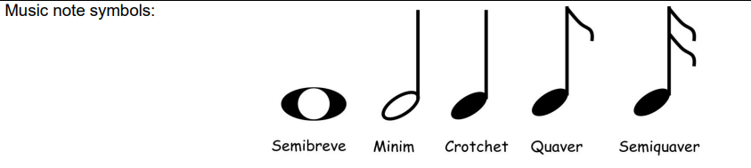  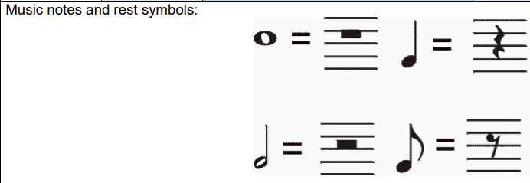
Year 5 | Prior Vocabulary plus –  Mood – a prevailing atmosphere or feeling created by the music.  Offbeat – the unaccented beat.  Chord – three or more notes (pitches) played together at the same time.  Octave – a range of eight whole notes, for example: middle C, D, E, F, G, A, B, C.  Ostinato – a repeated rhythm or phrase.  Slur – a curve over notes, suggesting that it is slurred together.  Staccato – short, sharp notes.  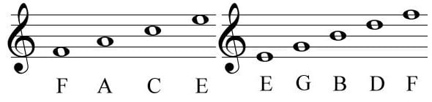
Year 6 | Prior Vocabulary plus –  Harmony – pleasing combination of two or more notes, played in background behind melody.  