Willow Primary Academy
Physical Education Curriculum
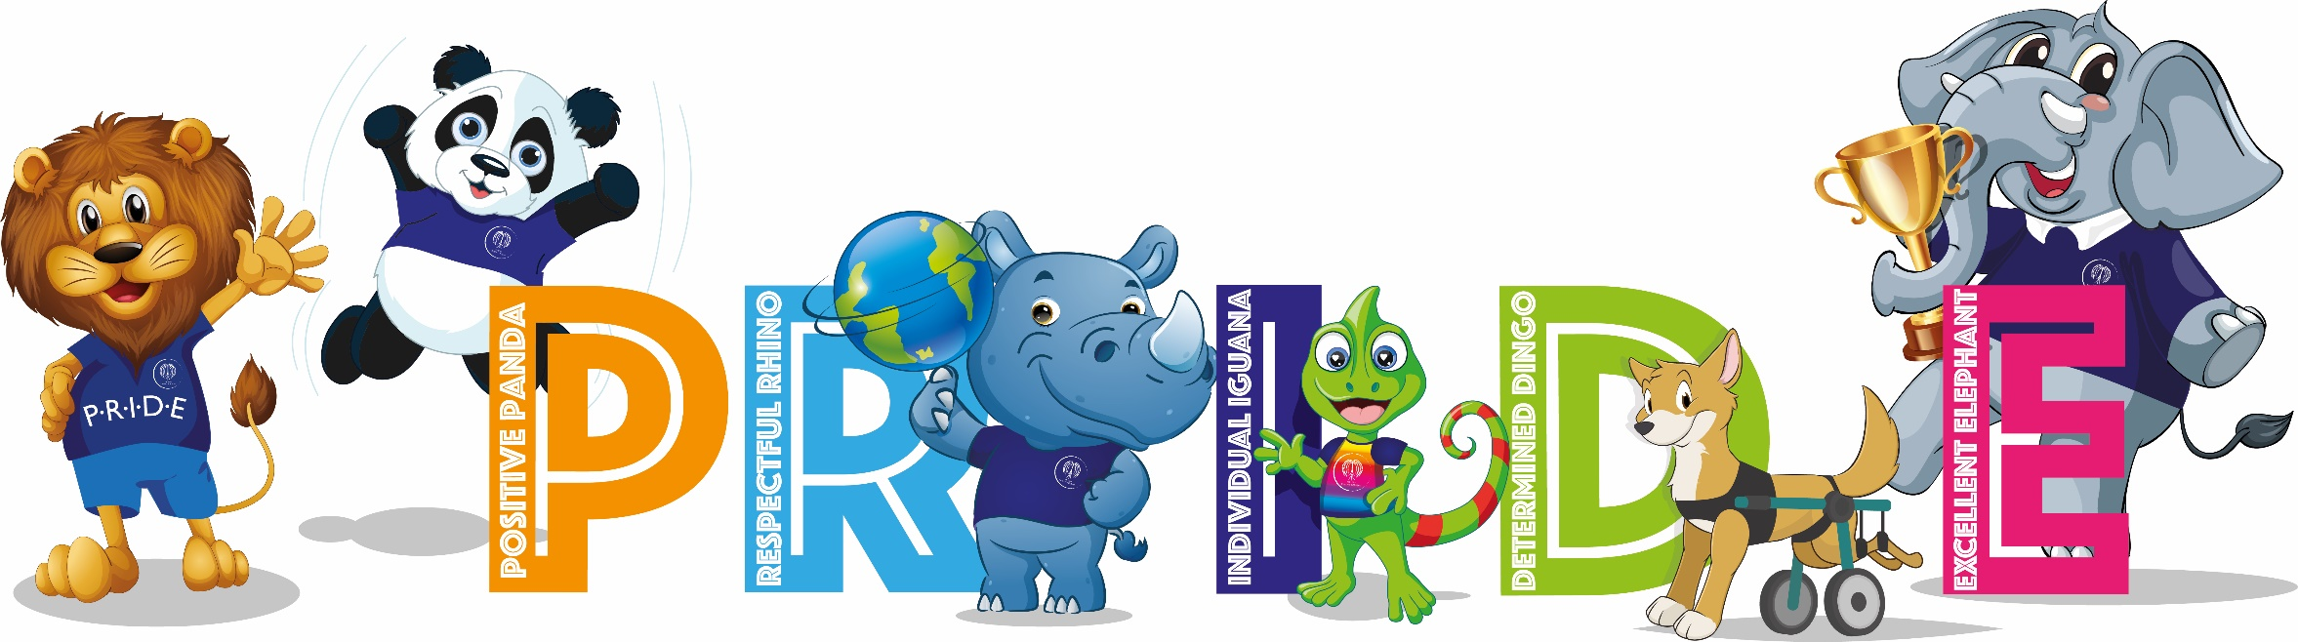
“Exercise not only changes your body. It changes your mind, your attitude and your mood.” Ms Ray

INTENT
At Willow Primary Academy we wish to promote physical, social, emotional and intellectual development of all children. We want pupils to experience a wide variety of sports and physical skills which will enhance lifelong positive attitudes towards physical activity. We believe that Physical Education (PE), experienced in a safe and supportive environment, is essential to ensure children attain optimum physical and emotional development and good health. We intend to deliver high-quality teaching and learning opportunities that inspire all children to succeed in physical education and in developing life skills. We want to teach children skills to keep them safe, such as being able to swim. We also want to teach children how to cooperate and collaborate with others as part of an effective team, understanding fairness and equity of play to embed life-long values. Our curriculum aims to improve the wellbeing and fitness of all children at Willow, not only through the sporting skills taught, but through the underpinning values and disciplines PE promotes.

IMPLEMENTATION
Delivery
- Teachers plan effectively using the Cambridgeshire Scheme.
- Each unit has an overview page that summarise the objectives, key concepts, resources required, links to other topics, the core task and a lesson-by-lesson outline.
- The equipment/apparatus required in each lesson is indicated to enable pupils to successfully participate in the suggested activities.
- Learning Objectives identify the learning outcomes for the specific unit of work and are related specifically to the NC programmes of study. They explain what should be taught and what pupils should be able to do, know and understand by the end of the lesson(s).
- Learning activities provide a range of suitable tasks which are specifically related to the learning objectives.
- Expectations identify the key learnings aspects on which teachers will make judgements about pupils’ progress and achievement and relate to the core task.
- Teaching points are listed, when appropriate, opposite the learning activity and are a guide to how to ensure pupils’ performance and development is of high quality.
- Key vocabulary is shown in the unit plans and teachers use and reinforce these consistently.
- Safety considerations are listed as a generic guide which teachers assess and adapt to their specific circumstances.

Progression
- Core Tasks are the key competencies that pupils will work towards to achieve progress in PE. The core tasks are an effective tool in ensuring that the curriculum is planned for progress and that pupils are learning and achieving at the correct rate. It is expected that most pupils will achieve the core task by the end of the unit.
- Each lesson has suggestions of ways to adapt teaching in order to support pupils to refine their performance and challenge the more able to excel.
- Learning outcomes are designed to progressively meet the expectations of the Core Task for that unit of work.
- Many assessment opportunities relate directly to the unit expectations and are listed in the assessment focus.
- In EYFS, children have a number of opportunities to negotiate space and obstacles safely considering themselves and others. They have plenty of opportunities to move energetically by running, jumping, dancing, hopping, skipping and climbing. They also have opportunities to demonstrate balance, strength and co-ordination whilst playing.
- In Key Stage One, pupils will develop fundamental movement skills, become increasingly competent and confident and access a broad range of opportunities to extend their agility, balance and co-ordination, individually and with others. They will engage in competitive and co-operative physical activities, in a range of increasingly challenging situations. They will master basic movements including running, jumping, throwing and catching as well as balance, agility and co-ordination. Pupils will begin to apply these in a range of activities and participate in team games, developing simple tactics for attacking and defending and perform dances using simple movement patterns.
- In Key Stage Two, pupils will continue to apply and develop a broader range of skills. They will develop an understanding of how to improve in different physical activities and sports and learn how to evaluate and recognise their own successes. Pupils will play competitive games, for example, cricket, hockey, netball and football, and apply basic skills and principles suitable for attacking and defending. They will further develop flexibility, strength, technique control and balance through athletics and gymnastics. Pupils will perform dances using a range of movements and compare performance with previous ones. Throughout, they will demonstrate improvement to achieve their personal best.

IMPACT
At Willow Primary, we ensure that our PE curriculum is progressive and allows children to develop fundamental skills and apply them to a variety of sports and activities. All children are provided with the opportunities to develop skills and to achieve their personal best. We encourage our pupils to be physically active and this has positive implications on their learning in the classroom. Children understand how to lead a healthy lifestyle and understand the importance of exercise. We hope children enjoy PE and develop a love of sport, and physical activity, that they pursue outside of school and in future life. All pupils understand the values and importance of fair play and being a good sportsperson. Year 6 pupils leave school with the skills to self-rescue in the water and swim 25 metres competently.

Long Term Plan – 2022 – 23
 | Term 1 |  | Term 2 |  | Term 3
FS | Evident in all projects and through enhanced provision
Year 1 | Multi-skills | Dance | Gymnastics | Dance | Gymnastics | Multi-skills
Year 2 | Multi-skills | Dance | Gymnastics | Dance | Gymnastics | Multi-skills
Year 3 | Netball | Dance | Gymnastics | Swimming | Cricket/Rounders | Athletics
Year 4 | Hockey | Dance | Gymnastics | Swimming | Tennis/Rounders | Athletics
Year 5 | Football | Dance | Gymnastics | Netball | Swimming | Athletics
Year 6 | Rugby | Dance | Gymnastics | Hockey | Swimming | Athletics

