Willow Primary Academy
Science Curriculum
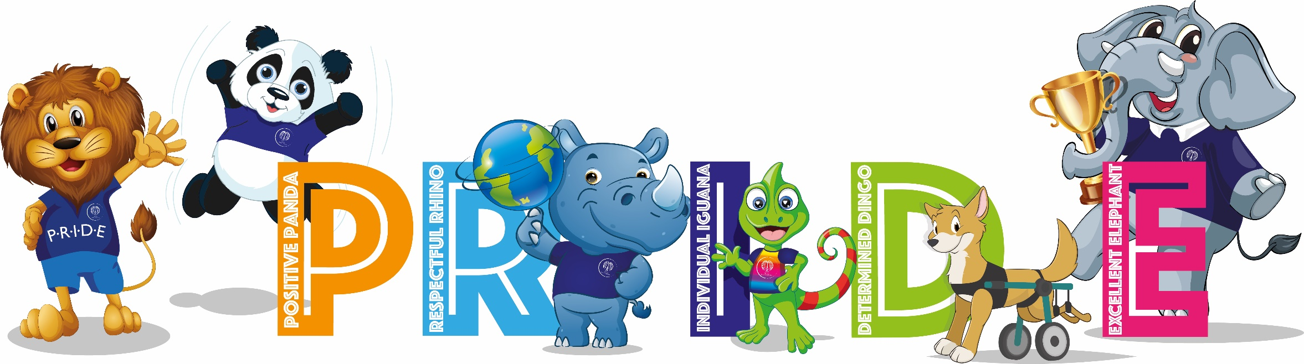
“The science of today is the technology of tomorrow.” – Edward Teller

INTENT
At Willow Primary Academy, our science curriculum is designed to develop a sense of excitement, curiosity and fascination about natural phenomena that will remain with the children for the rest of their lives. We want children to gain an understanding of scientific processes and an awareness of the uses and implications of science, today and for the future. From Reception to Year 6, our pupils will build a foundation of key knowledge and concepts, as well as develop skills in scientific enquiry and questioning. We actively encourage children to be inquisitive and develop their natural curiosity, whilst increasing pupils’ knowledge and understanding of our world. The aim is for scientific enquiry to form a common thread through the curriculum, helping children to understand that science is just as much about what they do as about what they know. We aim to maximise the opportunities for every child so that they know more, remember more and understand more about science.

IMPLEMENTATION
Delivery
- Teachers plan effectively using the Cornerstones Curriculum Maestro.
- Teachers map out learning using the planning tool.
- Four core elements that make up the teaching and learning approach:
      - Engage
      - Develop
      - Innovate
      - Express
- Names of science projects are matched to the national curriculum aspects, however in KS1 Animals, including humans has been separated so that children study humans before expanding to explore animals.
- Unit outcomes and suggested content enable good planning, progression and consistency across the school.
- Key questions are used to open up the content to be studied.
- Assessment takes place during learning to address misconceptions, identify strengths and gaps and inform next steps.
- Cross-curricular links are used whenever possible, i.e. Literacy, Art and Computing.
- Children’s lessons are enriched using outdoor learning, educational visits, expert science visitors, scientific resources, books and the internet.
- Science specific displays are put up in each class that showcase children’s work and highlight vocabulary.

Progression
- Science programmes of study are assigned to year groups.
- The Science curriculum is designed to progressively develop the children’s skills in Science from Reception through to year 6.
- Science is taught in projects that enable pupils to study in depth.
- Each project builds on prior learning, including EYFS, to ensure better cognition and retention.
- Each project has a clear overview outlining key concepts, knowledge, skills and vocabulary to be taught and evaluated to measure impact.
- Differentiation is used to enable every pupil to meet the learning objective, e.g. adult support, scaffolding, peer work.
- The projects are sequenced to develop both children’s knowledge and skills and enables them to make meaningful links to other projects.
- Links allow for children to embed their knowledge in new and often real-life contexts.
- Each projects place in the year has been carefully considered so they are positioned at a suitable time in the year to give pupils chance to make first-hand observations.
- Physics is not formally introduced until KS2, however in KS1 children have opportunities to explore natural phenomena, such as shadows.
- From EYFS children are encouraged to explore their natural world and make observations. This is mainly done through play, stories and discussion.
- In KS1, children look more closely at the natural and humanly-constructed world around them. They are encouraged to ask questions and be curious. Their understanding of scientific ideas is further developed and they being to use scientific enquiry to answer questions. First-hand practical experiences should be used for most of the learning and scientific language is used to talk about what they find out and communicate their ideas.
- In lower KS2, children broaden their scientific view of the world around them by exploring, discussing, testing and developing ideas about everyday phenomena and by beginning to develop their ideas about functions, relationships and interactions. They begin to ask their own questions and make decisions about which types of scientific enquiry are likely to be the best for answering them. Children begin to draw conclusions and use scientific language to talk and write about their findings.
- In upper KS2, children are enabled to develop a deeper understanding of a wide range of scientific ideas. They are given opportunities to explore and discuss their ideas, ask their own questions and analyse functions, relationships and interactions systematically. Children will encounter more abstract ideas and begin to use these to understand and predict how the world operates. Children will use scientific enquiry, including observing changes over time, noticing pattern, carrying out fair tests and using a wide range of secondary sources of information. Pupils will draw conclusions based on data and observations and use the evidence to justify their ideas and explain their findings.

IMPACT
The approach to Science at Willow results in a fun, engaging, high-quality science education that provides children with the foundations and knowledge for understanding the world. Children will know more, remember more and understand more about the Science curriculum. Children retain prior-learning and explicitly make connections between what they have previously learned and what they are currently learning.
All children will have:
- A wider variety of skills linked to both scientific knowledge and understanding, and scientific enquiry/investigative skills
- A richer vocabulary which will enable them to articulate their understanding of taught concepts
- Confidence and a love of learning for all things science.

Long Term Plan – 2022 – 23
 | Term 1 |  | Term 2 |  | Term 3
FS | Exploring Autumn |  | Starry Night | Signs of Spring  Ready Steady Grow | Animal Safari | On The Beach
Year 1 | Everyday materials | Humans Senses | Seasonal Changes |  | Plant parts | Animals Parts
Year 2 | Human Survival | Habitats | Uses of materials | Plant Survival | Animal Survival
Year 3 | Skeletal and muscular systems |  | Forces and Magnets |  | Plant Nutrition and Reproduction | Light and Shadows
Year 4 | Digestive System | Sound | Electrical circuits and conductors |  | States of matter | Grouping and classifying
Year 5 | Forces and mechanisms | Earth and Space | Human Reproduction and Ageing |  | Properties and changes of materials
Year 6 | Circulatory System |  | Electrical circuits and components |  | Light Theory | Evolution and Inheritance

