Willow Primary Academy
The Piper Centre

Lunchbox and Snack Policy
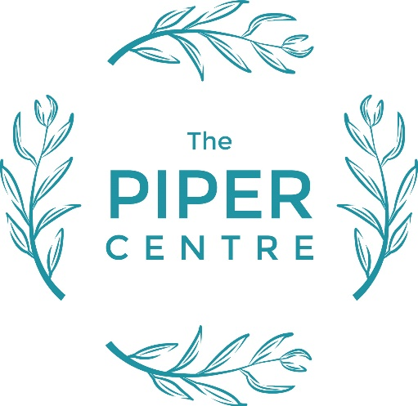

Willow Primary Academy
The Piper Centre –
Taking PRIDE in all we do

Promoting Positivity, Nurturing Respect, Celebrating Individuality, Fostering Determination, Striving for Excellence
Policy Review Schedule

Date agreed: September 2023
Next review due: September 2027
Distributed to staff: September 2023
Signed by SLT: P Hales
Signed by chair of governors:

Aim

Our aim is to ensure that all packed lunches brought from home and consumed in school provide the children with healthy and nutritious food and drink.

Objectives

- To ensure that we give consistent messages about food and health
- To give our pupils and parents the information they need to make healthy choices
- To promote health awareness
- To encourage all children to take part in the ‘5 a day’ campaign This policy applies to all children and parents providing packed lunches to be consumed within Willow Primary Academy.

Food in packed lunches

- For children having a packed lunch at Willow Primary Academy a lunch box will need to be provided and clearly labelled.
- The school will provide clean and appropriate dining room arrangements.
- Parents are advised that, in hot weather, insulated lunch boxes/bags and freezer blocks should be used.
- Any food that is not consumed will be returned in the lunch boxes to enable parents to recognise what their child has/has not eaten.
- For health and safety reasons, children are not permitted to swap or share food items.

A healthy and balanced lunchbox is recommended to include the following every day:

- At least one portion of fruit or one portion of vegetables e.g., carrot sticks, cucumber, small apple or orange, banana, dried fruit, cherry tomatoes, mango cubes.
- Meat, fish, or other source of non-dairy protein e.g., chicken, turkey, ham, beef, pork, tuna, lentils, kidney beans, chickpeas, falafel
- A starchy food e.g., bread, pasta or rice, crackers, rice cakes, oat cakes, pitta break, tortilla wraps.
- Dairy food e.g., cheese, yoghurt or fromage frais.
- A non-fizzy drink, preferably water, fruit juice or sugar free squash.

We suggest that children do not regularly have crisps or chocolate as part of their lunch. Alternative suggestions are as follows:
- Savoury crackers or breadsticks served with a dip
- Vegetables and fruit
- Cereal bar
- Dried fruit
- Sugar free jellies with fruit
- Scones (plain or with dried fruit)
- Fruit based cake (e.g., carrot cake, gingerbread, banana loaf, date loaf, fruit loaf (or the same but in the form of a muffin)
High fat meat products such as sausage rolls, individual pies, corned meat, and sausages should only be included occasionally.

Special diets and allergies:
- The school recognises that some pupils may have dietary requirements that may contravene the health standards stated in this policy. In these cases, parents are responsible for ensuring that packed lunches are as healthy as possible.
- For this reason, children are also not permitted to swap food items.

At no time will a child feel ashamed or uncomfortable about their lunch box's contents.

Healthy Snacks
All children in Reception and KS1 receive a free piece of fruit or vegetable everyday as part of the Governments School Fruit and Vegetable Scheme.

As children move up into KS2, if they wish to have a break time snack, they are currently required to bring in something from home. No chocolate or sweets should be sent to school. Crisps are not recommended as a healthy snack. Examples could include:
- Fresh fruit
- Dried fruit
- Vegetables (e.g., carrot or cucumber sticks)
- Crackers
- Bread sticks
- Low-fat cereal bars

Treats that are sent into school to celebrate birthdays are allowed. Where possible these will be distributed at home time, so parents are able to monitor this

Curriculum Links
Within our Curriculum Healthy Eating is taught within all year groups. For further information this can be found within the PSHE Progression document

Dissemination of the policy
- The school will share this policy on the school website, willow.sandmat.uk
- All governors and staff will be aware of/and adhere to this policy.
- This policy will be reviewed in September 2026 or earlier if required.

