Things you could do at home to practise being ready for Year 1:

Practicing your number facts like counting in 2s and number bonds to 10

Reading books that you enjoy everyday

Practicing your writing. Can you write short sentences?

Have a look around your house and think about what different items might be made from

**Have a great summer! See you in September!**



Year 1

Ash Class



Meet the grown-ups in Year 1:

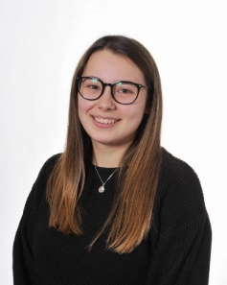

Hello everybody! I am **Miss Green** and I am so excited to be your teacher in September! This Is my second year at Willow in year 1 and I’m looking forwards to us all growing and learning together. Have a brilliant summer!

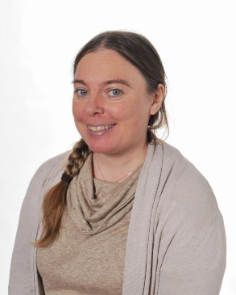

Hello, I am **Mrs Smith,** I will be your learning partner everyday and I am very excited to see you in Ash class next year! I love to read, my favourite books are Harry Potter and Matilda.



Hi, I’m **Miss Tocknell** and I will be in Ash class Monday to Wednesday afternoon. I love to play games and have fun. I can’t wait to meet you all in September!



Hello, I'm **Miss Cornock** and most of you will know me from being outside at playtimes. I will be your learning partner on Wednesday afternoons, Thursdays and Fridays. Have a lovely summer and I look forward to seeing you all in September!

Our learning environment

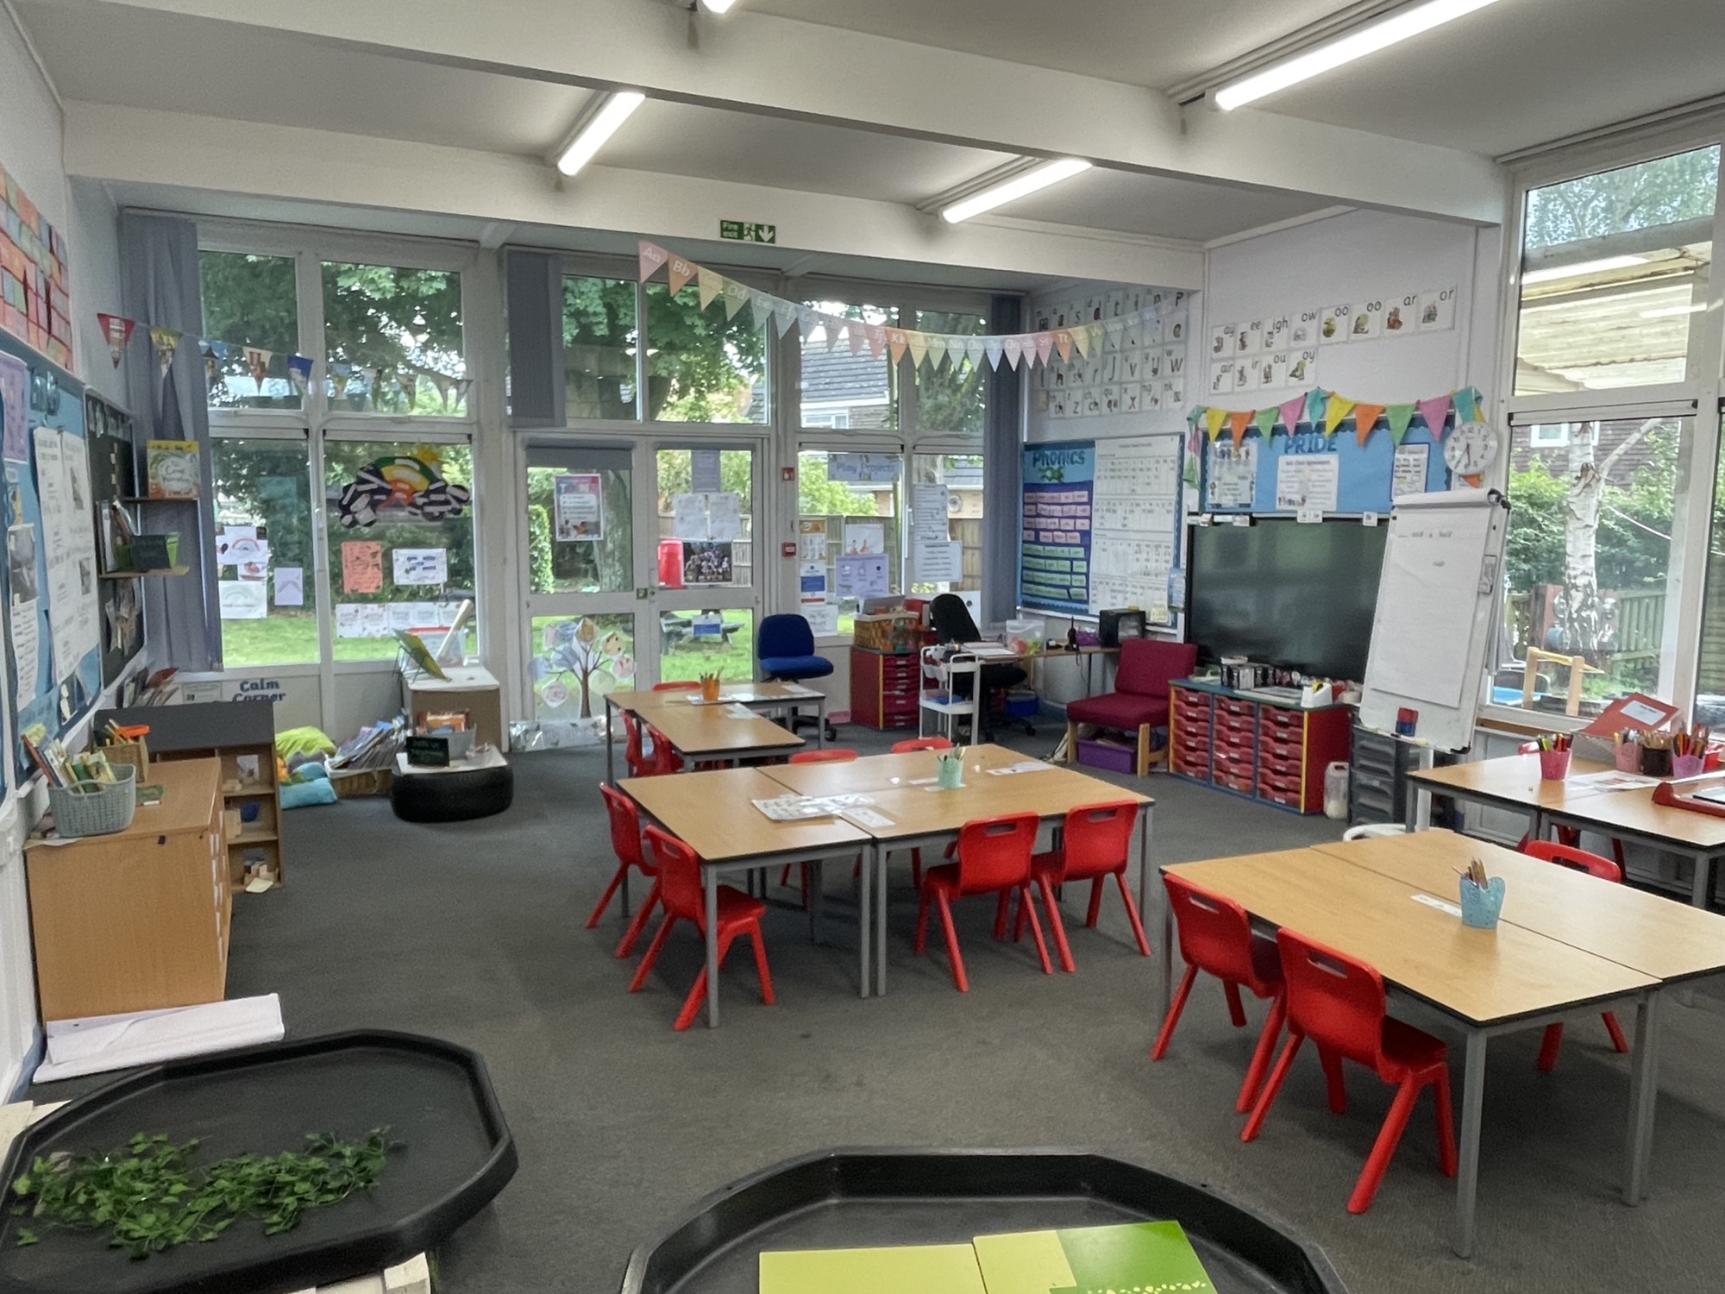

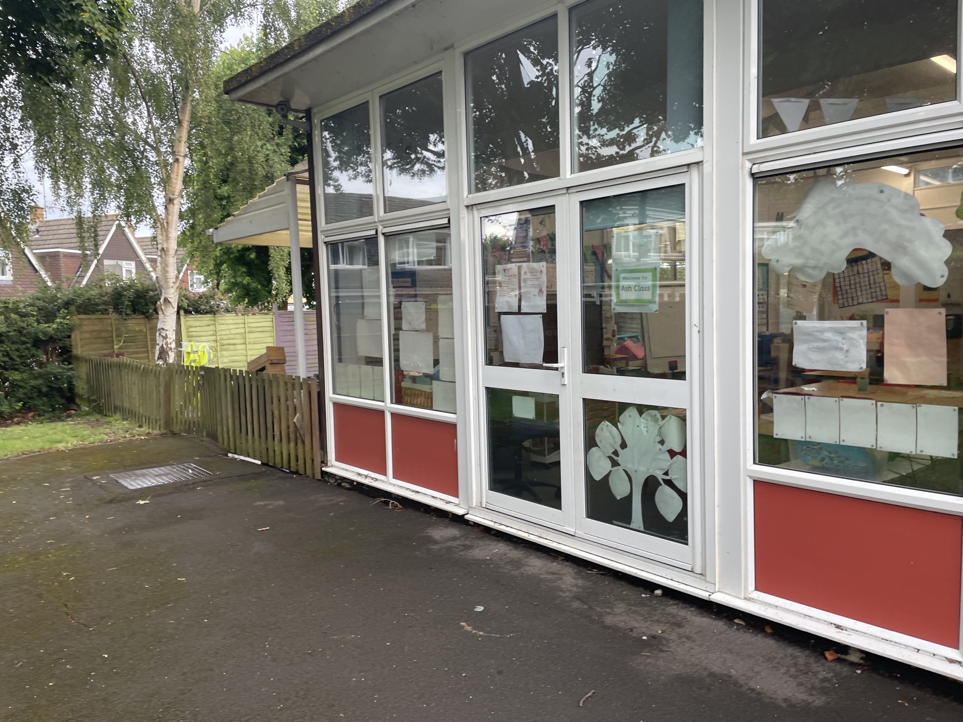

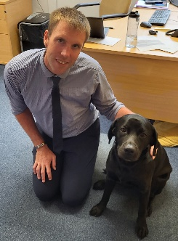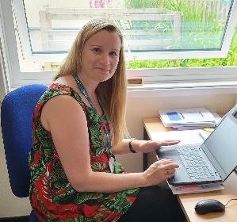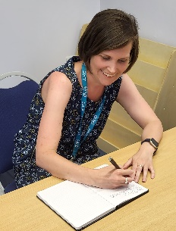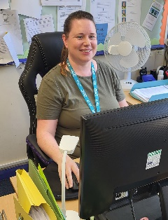

Here are some other familiar faces you will see at Willow!

This is Mrs Tonks. She is the Deputy Head Teacher and teacher of Elm Class. She leads the development of our exciting curriculum!

This is Mr Hales and Nico. Mr Hales is the Head Teacher at school and Nico is our school dog. He loves having cuddles with the all of the children and adults that come to school.

This is Mrs Hendry. She is always available to support the families and to ensure that everyone is safe!

This is Mrs Sullivan. She is always available in the Office and helps to make sure the parents have all the information they need!

Our PRIDE Values

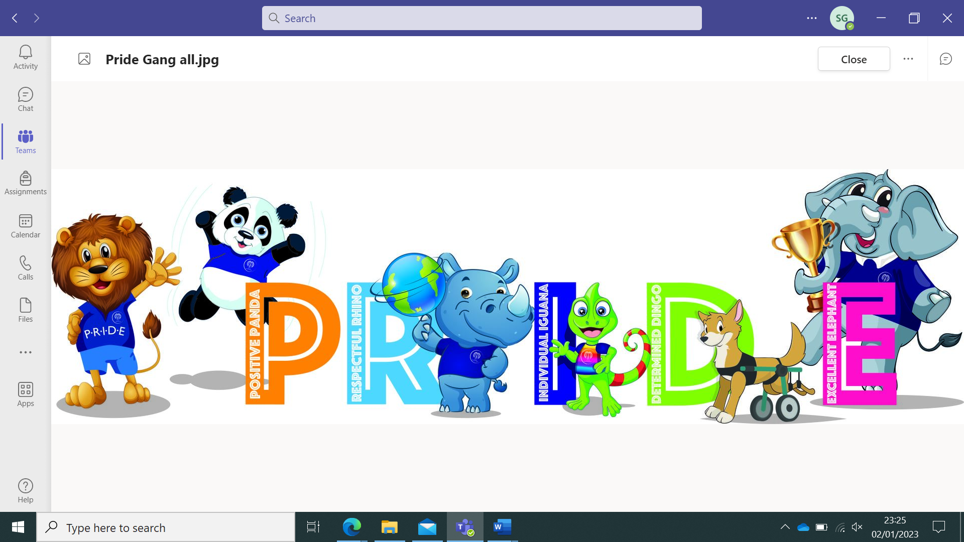

**POSITIVITY** - We value our children’s happiness and encourage our pupils to work together and support each other by promoting positivity through the curriculum we offer

**RESPECT** - We value the importance of respect and nurture children’s ability to listen to and respond to the views of others, including people of all cultures. We tr. eat them with fairness and honest

**INDIVIDUALITY** - We value the way in which all children are unique and our curriculum enables children a variety of opportunities to express themselves in different ways. We enable each child to be successful and we provide equal opportunities for all the children in our school.

**DETERMINATION** - We value and foster determination and we aim, through our curriculum, to build children’s resilience. From the earliest opportunity, children are encouraged to develop independence, self-discipline and responsibility so they learn to embrace new challenges and experiences.

**EXCELLENCE** - We value children’s efforts and recognise that excellence can be shown in different ways depending on the child as an individual. We encourage children to strive to be the best that they can be.

In Year 1, we will learn…

**Here are some of the fun books that will be helping us with our learning:**

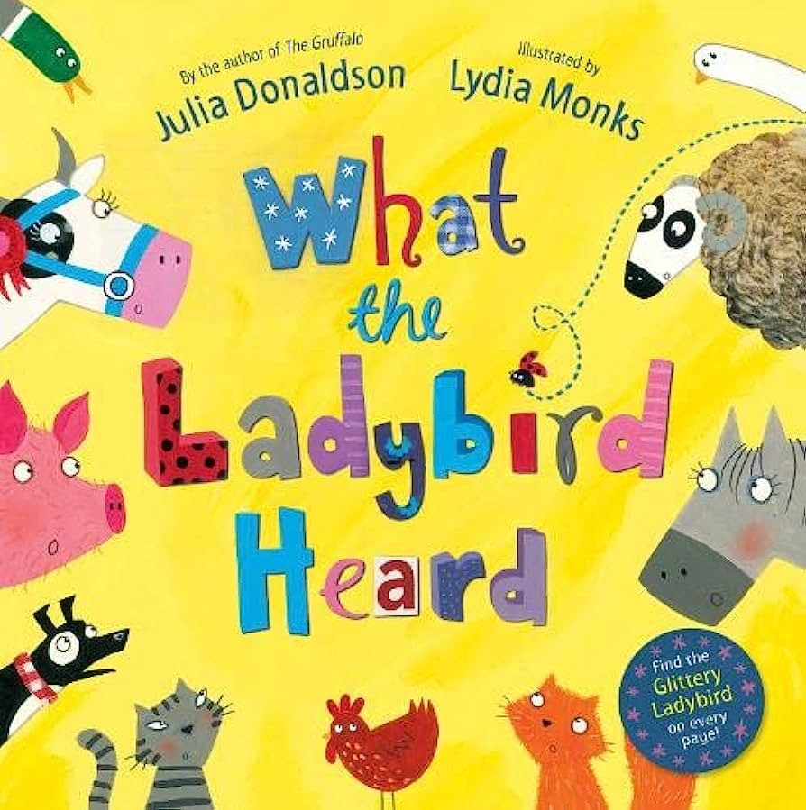 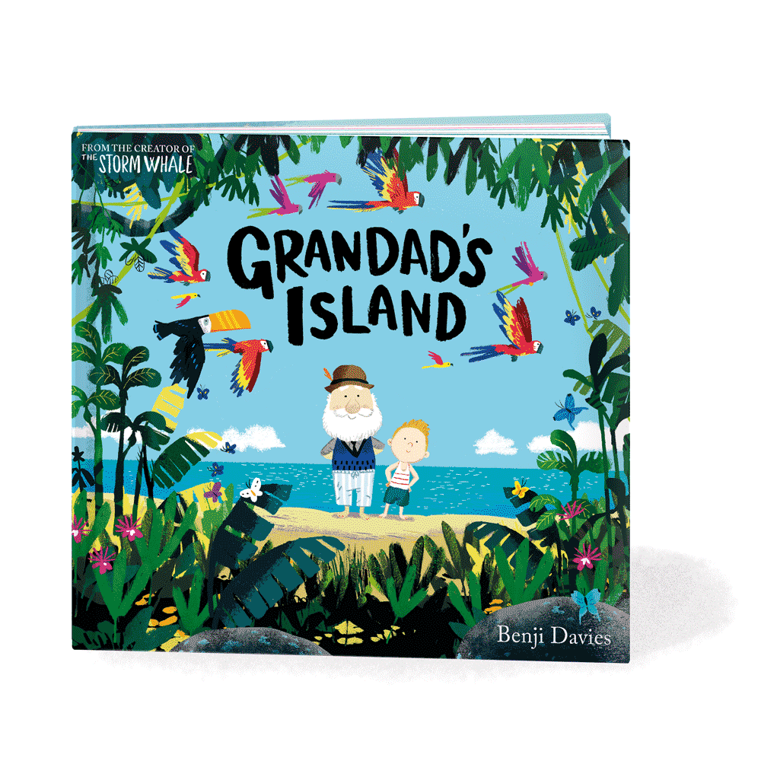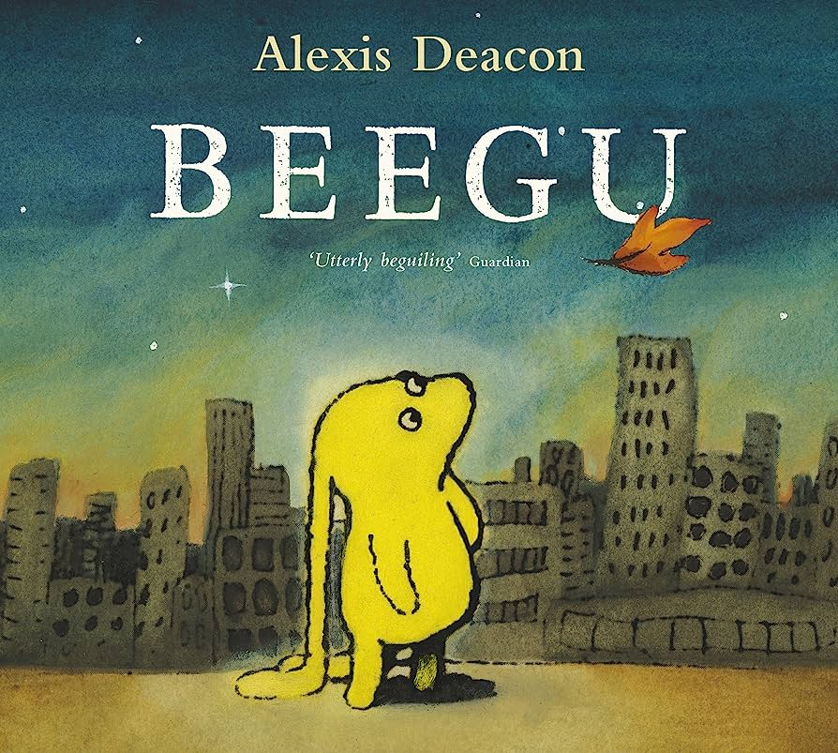

In RE, we will be thinking about what it means to belong to a faith community.

In Geography, we will learn all about our wonderful world.

In History, we will look at what it was like to be a child in the 1950s.

In Science, we will be looking at materials that we use or see everyday.

In PE, we will be learning some dance skills.

Visits, visitors and events to look forward to!

We will go back in time and take part in a Victorian lesson and use real artifacts from the past.

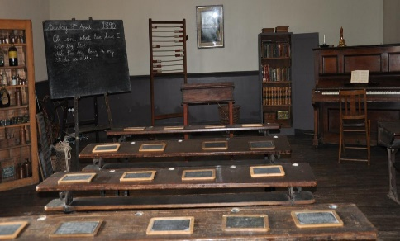

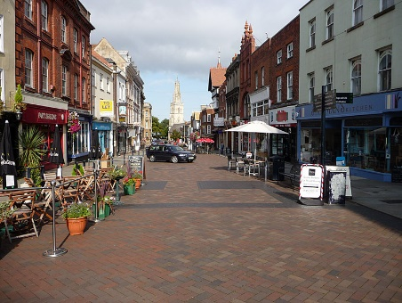

We will visit Gloucester city centre to spot the different features of a city.

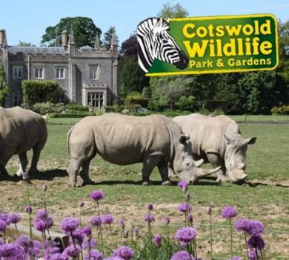

We will go on a trip to Cotswold Wildlife Park to see how many different type of animals we can see.