Handwriting is a tool of communication in the written form. All teachers should aim for the best that individual pupils can achieve. Handwriting is often linked to decoration and illustration, leading to a finished product which is pleasing to look at and which can be attractively displayed. Children can achieve a great deal of satisfaction and pleasure from the way they present their work.
Principles for Teaching and Learning:  Handwriting is a skill that needs to be actively taught  Children need to understand the purpose and audience for their handwriting  Handwriting sessions take place regularly and consistently, in a timetabled slot  Class Teachers follow the progression document for the introduction of letters and their associated joins across each year group |  | Progression in Handwriting  The Handwriting programme at Willow Primary Academy is based around four main development phases. They are:  Readiness for writing: Gross and fine motor skills leading to letter formation (Foundation Stage)  Beginning to join (KS1)  Securing the joins (KS1/Lower KS2)  Practising speed and fluency (Lower KS2)  Presentation skills (Upper KS2)
Reception
Initial handwriting will be taught as a whole class alongside RWI Phonics, using techniques such as air-writing, using the RWI mnemonics below. Early diagraphs will still be in print, not joined. All letters will be covered in RWI Set 1, except Q which will need explicit additional teaching when completing Qu.

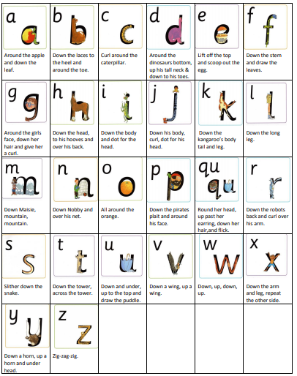
Year 1  Pupils will spend the first term practising the formation of lower case letters as part of words, e.g. common words and/or CVC, CCVC, CVCC words. This should continue to be teacher led as far as possible. Pupils should be ready to learn base line joins at the beginning of Term 5 (see below): | Revision  Lower case a - z  Child's full name  Capitals A - M  Capitals N - Z  Set 1 Set 2 Set 3 Set 4  ll all ar ip  li in aw up  ti un iv ib  il an hu ub  it im ti th  ill um ki ck  ut am du ch  at ine ay ent  ull ime ey ant
Year 2  Pupils should spend a few weeks revisiting base line joins before progressing on to top joins, joins to anti-clockwise letters and other joins. Handwriting should be taught as a whole class, but with additional activities for any children experiencing difficulties. | Top Joins  Set 1 Set 2 Set 3 Set 4 Set 5  ou re ob ve fe  ov ri ol we fi  ow rt ot wh fu  op rk of fl  if ft  Joins to anti-clockwise letters  Set 1 Set 2 Set 3 Set 4  ac oa fa ea  ad od fo ed  ag og va  ca oo wa  da ws  ha  Other joins  Set 1  Joins to e Joining from t Joining from p Joining from b Descenders – y, g, q, j (not joined) Descenders joined to e qu ff ss sw us ix
Years 3 & 4  Pupils will benefit from a regular handwriting lesson, teacher led. Handwriting can now focus on spelling. The expectation should be for pupils to be transferring their joined script to all areas of the curriculum. Pupils should be reminded and praised when they succeed. |  | Years 5 & 6  Pupils should now be encouraged to use their own fluent and legible style in all their writing. With good teaching from Reception to Y4, most pupils will be able to do so. If a pupil’s writing is still poor it is often simply the size of the letters that is inconsistent or the placing of them on the line. This may be tackled by teacher/pupil discussion or individualised and specific target setting.

Twinkl School Font  https://www.twinkl.co.uk/twinkl-font | 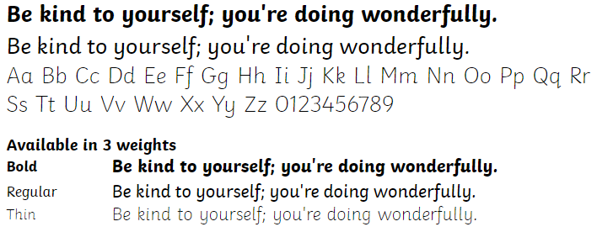
Twinkl Handwriting Font (cursive unlooped)  https://www.twinkl.co.uk/twinkl-handwriting-font | 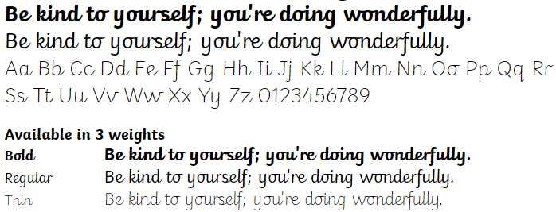

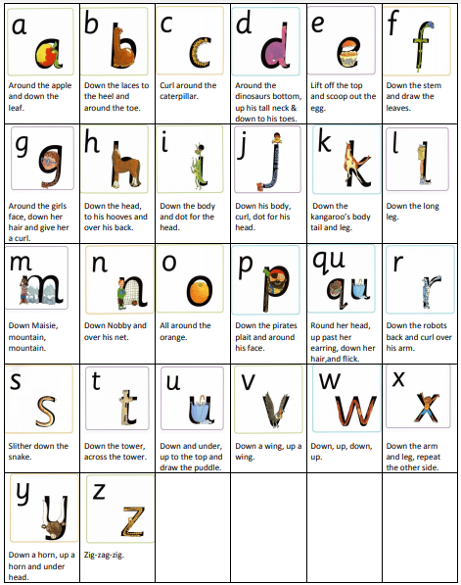

Aa | Bb | Cc | Dd | Ee | Ff | Gg
Hh | Ii | Jj | Kk | Ll | Mm | Nn
Oo | Pp | Qq | Rr | Ss | Tt | Uu
Vv | Ww | Xx | Yy | Zz
The quick brown fox jumps over the lazy dog.

Aa | Bb | Cc | Dd | Ee | Ff | Gg
Hh | Ii | Jj | Kk | Ll | Mm | Nn
Oo | Pp | Qq | Rr | Ss | Tt | Uu
Vv | Ww | Xx | Yy | Zz
The quick brown fox jumps over the lazy dog.

