Willow Primary Academy - Pupil premium strategy statement 2023-24

This statement details our school’s use of pupil premium (and recovery premium for the 2022 to 2023 academic year) funding to help improve the attainment of our disadvantaged pupils.

It outlines our pupil premium strategy, how we intend to spend the funding in this academic year and the effect that last year’s spending of pupil premium had within our school.

School overview
Detail | Data
School name | Willow Primary Academy
Number of pupils in school | 173
Proportion (%) of pupil premium eligible pupils | 45.7%
Academic year/years that our current pupil premium strategy plan covers (3 year plans are recommended) | 2023-24 to 2024-25
Date this statement was published | October 2023
Date on which it will be reviewed | July 2024
Statement authorised by | Pete Hales
Pupil premium lead | Pete Hales
Governor / Trustee lead | Katie Sweed
Funding overview
Detail | Amount
Pupil premium funding allocation this academic year: | £91,410
Recovery premium funding allocation this academic year: £145 per pupil | £13,845
Pupil premium funding carried forward from previous years (enter £0 if not applicable) | £0
Total budget for this academic year  If your school is an academy in a trust that pools this funding, state the amount available to your school this academic year | £105,255

Part A: Pupil premium strategy plan

Statement of intent
The effective use of Pupil Premium Grant (PPG) encompasses all elements of our mission, vision and core values. ALL pupils, including the most severely disadvantaged and most able, are regarded as unique individuals and receive both challenge and support designed to best meet their needs. We passionately believe that education plays a powerful and transformative role in improving life chances. We aim to do whatever it takes to remove any barriers that stand in the way of pupils achieving an excellent education. As such, our main purpose is to focus on closing the gaps in achievement and attainment that may exist for different groups of pupils in our academy.

Objectives:
- To diminish differences between our disadvantaged pupils and their peers
- To ensure that the attainment gap between disadvantaged pupils in school and disadvantaged pupils nationally remains low
- To provide pupils with high quality teaching and learning opportunities
- To provide effective social and emotional support to disadvantaged pupils so they are safe, happy and attend every day
- Ensure disadvantaged pupils have priority access to high quality recovery programmes in 2023/24
- Ensure disadvantaged children have access to a wide range of curriculum and extracurricular activities, in order to provide an enriched, relevant, engaging and innovative curriculum enabling children to uncover a world of possibilities

To ensure successful implementation of the plan, evidenced based strategies will be used to support the most disadvantaged pupils. A blend of educational recovery programmes alongside social and emotional programmes and support, will enable children and families to flourish during their time in school and at home.

Successful implementation will be achieved through a number of key principles in order to provide an enriched, relevant, engaging and innovative curriculum:
- Evidenced based strategies will be implemented to ensure the best impact on improving outcomes for disadvantaged pupils
- High quality teaching is the key to improve outcomes for disadvantaged pupils
- Every child has the right to succeed academically and children and their families will be supported socially and emotionally at all times
- We are committed to providing our disadvantaged pupils with access to a wide variety of curricular and extracurricular experiences and activities

PP funding will be allocated following a needs analysis which will identify priority classes, groups or individuals. Limited funding and resources mean that not all children receiving free school meals will be in receipt of pupil premium interventions at one time.

Challenges

This details the key challenges to achievement that we have identified among our disadvantaged pupils.
Challenge number | Detail of challenge
1 | High Levels of deprivation leading to a large child protection workload and SEMH support for our pupils.
2 | Ensuring attendance of disadvantaged children is inline with their peers across the school while reducing the levels of persistent absence across vulnerable groups in school.
3 | Historically low levels of parental aspiration.
4 | Historically low levels of attainment on entry.
5 | School readiness, including: speech and language.

Intended outcomes
This explains the outcomes we are aiming for by the end of our current strategy plan, and how we will measure whether they have been achieved.
Intended outcome | Success criteria
To close the gap in attainment between  disadvantaged pupils and their peers. | - Internal school attainment data will demonstrate that the gap is diminishing between disadvantaged pupils and their peers.  - Outcomes at the end of Key Stage 2 will demonstrate that the attainment and progress gap for disadvantaged pupils at Willow is in line with national.
To ensure every child has access to  high quality teaching, in every classroom,  every day. | - Standards of teaching will be graded at least good. This will be evidenced through the monitoring cycle and teacher triangulation.  - A comprehensive catalogue of CPD support and training accessed by teachers and Learning Partners.
To improve attendance of all pupils and  diminish differences between  disadvantaged pupils. | - School attendance target of 95% met.  - Attendance of disadvantaged pupils in line with attendance of their peers.  - Persistent absence reduced and inline for disadvantaged pupils and their peers.  - Strategies to improve attendance have a positive impact: Breakfast club, rewards, pastoral support.
To ensure that all pupils have access to  high quality mental health and well-being  support. | - Outcomes of pupils questionnaires and pupil voice are positive.  - Parental feedback via questionnaires is positive indicating they feel well supported by the school.  - High quality CPD for all staff so they are able to identify and support vulnerable pupils.
To ensure all pupils are able to read  fluently, and with confidence, in any  subject, creating a clear transition from ‘learning to read to reading to learn’  across all subjects. | - Reading remains an overarching priority.  - Phonics outcomes at the end of Year 1 exceed national expectations.  - Reading outcomes and progress at the end of Key Stage 2 Is closer to national expectations.  - Attainment and progress for disadvantaged pupils to diminish the gap with their peers  - Regular Pupil voice and monitoring of reading demonstrates that children have a love of reading and have transitioned from ‘learning to read’ to ‘Reading to learn’.
To ensure that the recovery curriculum  programmes are prioritised for  disadvantaged pupils and that they make  good progress on catch up. | - GL baseline assessments will support prioritises in 2022/23.  - Reading remains an overarching priority in 2022/23.  - Pupils will make at least good progress in lessons.  - Pupils will make at least good progress in interventions which are measured against a baseline starting point.

Activity in this academic year
This details how we intend to spend our pupil premium (and recovery premium funding) this academic year to address the challenges listed above.

Teaching (CPD, recruitment and retention)
Budgeted cost: £15,876
Activity | Evidence that supports this approach | Challenge number(s) addressed
External Staff CPD  Targeted and bespoke external CPD delivered to staff to ensure high quality Teaching and learning across the school. | High Quality Teaching | 4, 5
SALT  Speech and Language therapist. Support from Qualified Speech and Language Therapists ensures both speech and language processing issues are identified and supported for key children across the school. | Oral language interventions  One to One tuition | 5
Subscriptions  Spelling Shed, Doodle Maths and English. | Using Technology to Improve Learning | 3, 4, 5

Targeted academic support (tutoring, one-to-one support structured interventions)
Budgeted cost: £32,000
Activity | Evidence that supports this approach | Challenge number(s) addressed
Phonics and Reading interventions in  KS1 and KS2, including 1:1 reading:  Daily phonics interventions delivered  across Key Stage 1 and 2. | Phonics  Small group tuition  One to One tuition | 4, 5
Mental Health Development  A year long intervention to train children in understanding mental health | Behaviour interventions  Social and Emotional Learning | 1, 2

Wider strategies (related to attendance, behaviour, wellbeing)
Budgeted cost: £43,124
Activity | Evidence that supports this approach | Challenge number(s) addressed
Family Support Worker  - Home Issues  - Behaviour  - Attendance  - Intervention | Behaviour interventions  Social and Emotional Learning | 1, 2
Parental Workshops | Parental Engagement | 2, 3, 4
Breakfast Club | Breakfast Clubs | 1
Attendance rewards and incentives | DfE Evidence Report | 2
ELSA intervention  (Emotional Literacy Support) | Behaviour interventions  Social and Emotional Learning | 1, 2
Play Therapy | Behaviour interventions  Social and Emotional Learning | 1, 2

Total budgeted cost: £105,255

Part B: Review of outcomes in the previous academic year

Pupil premium strategy outcomes
This details the impact that our pupil premium activity had on pupils in the 2022 to 2023 academic year.
Reading
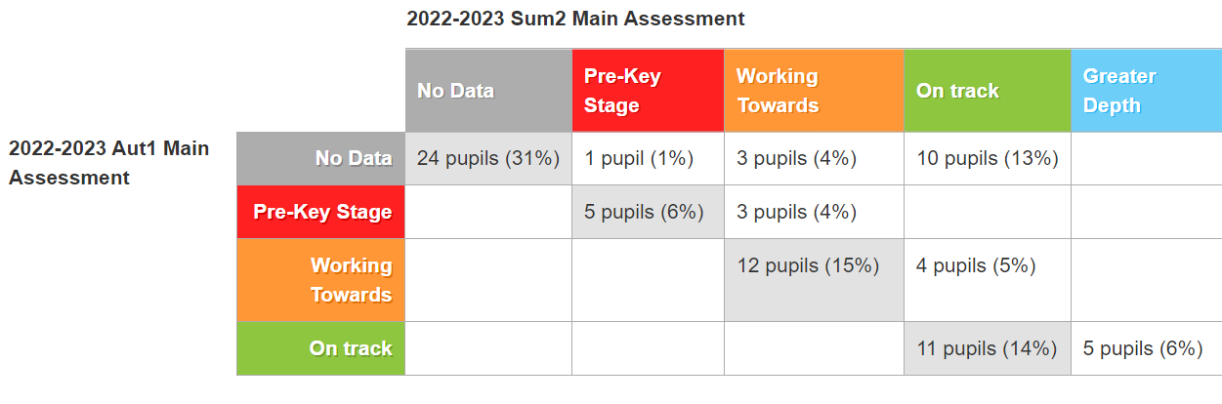
The reading data shows that:
- 12 disadvantaged pupils (14.8%) have made better than expected progress;
- 28 disadvantaged pupils (34.6%) have made expected progress;
- 24 disadvantaged pupils (31%) had no previous data.

Writing
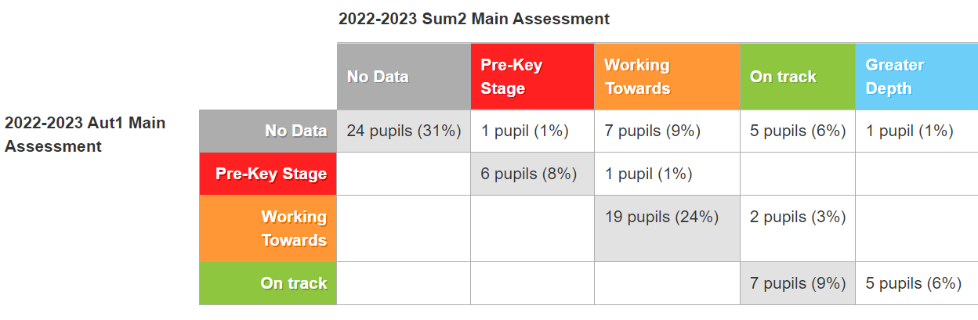
The writing data shows that:
- 8 disadvantaged pupils (9.9%) have made better than expected progress;
- 32 disadvantaged pupils (39.5%) have made expected progress;
- 24 disadvantaged pupils (31%) had no previous data.

Maths
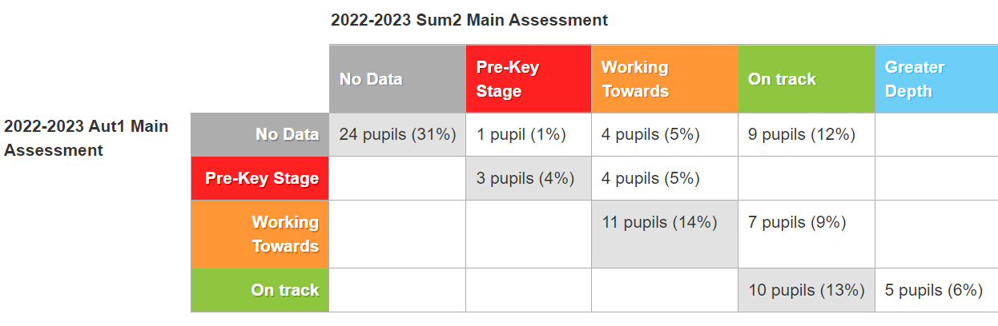
The maths data shows that:
- 16 disadvantaged pupils (19.8%) have made better than expected progress;
- 24 disadvantaged pupils (31%) have made expected progress;
- 24 disadvantaged pupils (31%) had no previous data.

Attendance
Due to the implementation of additional Family Support and rewards and incentives for attendance Willow saw an increase of overall attendance by 2.13%.
There was also a decrease in persistent absence by 8.58%

 | Whole school | Piper Centre | Willow | Whole school | Piper Centre | Willow
Total attendance | 90.64% | 88.6% | 90.97% | 92.41% | 88.9% | 93.1%
Persistent absentee percentage | 25% | 14.29% | 27.1% | 20% | 28% | 18.52%
Persistent absentee number of pupils | 30 | 3 | 27 | 32 | 7 | 25

ELSA
19 children received the ELSA intervention throughout the academic year. Sessions are confidential, but any short reports can be found on CPOMS for individual children.

Standardised Tests
The purchase of NFER standardised tests for reading and maths supported teachers with their end of term assessments. There were minimal discrepancies between teacher judgements and test outcomes.

SALT
Speech and Language Therapist has been provided throughout the academic year. The initial focus has been on children in Reception Class. The progress matrix below demonstrates the impact on disadvantaged pupils in Reception

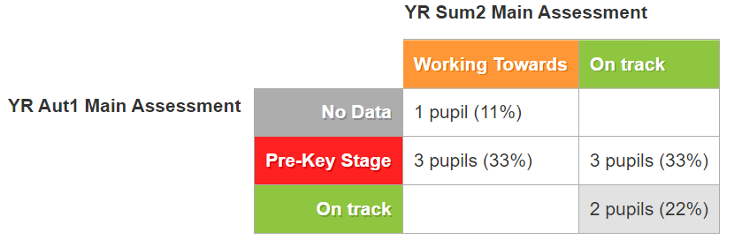

Externally provided programmes
Please include the names of any non-DfE programmes that you purchased in the previous academic year. This will help the Department for Education identify which ones are popular in England
Programme | Provider

