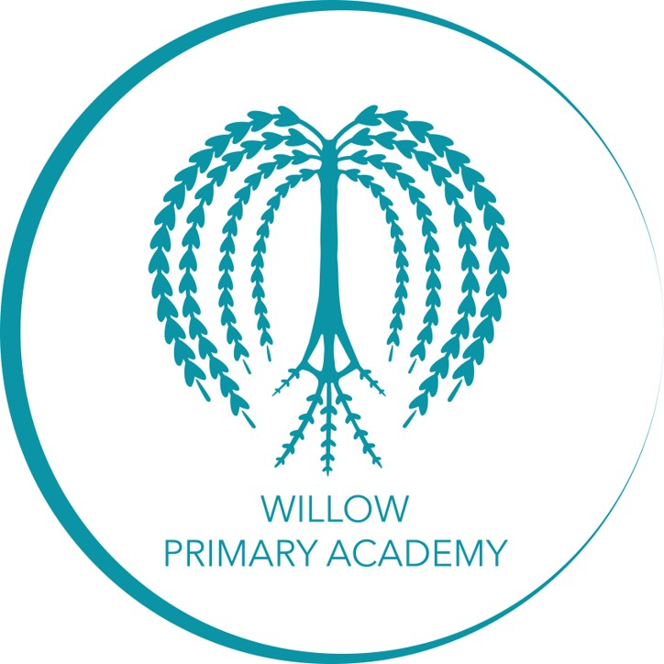

Curriculum Policy

Approval confirmed:

Designation | Name | Date | Signature
Curriculum lead: | Carly Tonks | 07.09.23 | 
Headteacher: | Pete Hales | 1.9.22

Monitoring and Evaluation
Original implementation date: | 01.09.22
Review date: | 7.5.24
Date of next Review: | 1.7.25
Review delegated to: | Carly Tonks

Vision
At Willow Primary Academy we empower all children to fulfil their true potential by fostering their love of learning; nurturing their personal development; and enabling them to feel proud of their own achievements.

Aims
It is our aim that by the time the children leave Willow to embark on the next stage of their education, they are equipped with the academic skills and knowledge, and have developed the personal attributes needed to enable them to become successful citizens of the future. The school curriculum's main aim is to provide a wide range of learning opportunities and experiences. It is our hope that children and their families value their learning and make use of any opportunity wholeheartedly, therefore we aim to ensure the offer to learn is strong in every classroom.

The National Curriculum forms one part of the school curriculum. There is time and space in the school day and in each week, term and year to work beyond it. The National Curriculum provides an outline of core knowledge around which teachers can develop exciting and stimulating lessons to promote the development of pupils’ knowledge, understanding and skills as part of the wider school curriculum.

Our school curriculum not only includes the expectations of the National Curriculum, but also a range of enrichment activities to extend the pupils understanding of themselves and the world in which they live. We call these the Willow Wonders. At Willow, we believe that effective learning takes place when there is considerable emphasis on opportunities to talk both imaginatively, expressively and to explain and clarify thinking. At Willow Primary, we expect everyone to develop and show a sense of pride and take responsibility whether alone, together at work or at play, and to support each other.

Our curriculum also ensure that all teachers and other professionals possess expert levels of knowledge in the subjects they teach and supports all teachers and other professionals in being “lifelong learners”, committed to an ongoing development of their own knowledge and skills to optimise the pupils’ learning experiences.

Values
Everything we do at Willow Primary Academy is underpinned by our school PRIDE values that we hold dear. We encourage everyone to live by our mission statement ‘Taking PRIDE in all we do’. Each letter of PRIDE also has its own value.

- Positivity - We value our children’s happiness and encourage our pupils to work together and support each other by promoting positivity through the curriculum we offer.
- Respect - We value the importance of respect and nurture children’s ability to listen to and respond to the views of others, including people of all cultures. We tr. eat them with fairness and honest
- Individuality - We value the way in which all children are unique and our curriculum enables children a variety of opportunities to express themselves in different ways. We enable each child to be successful and we provide equal opportunities for all the children in our school.
- Determination - We value and foster determination and we aim, through our curriculum, to build children’s resilience. From the earliest opportunity, children are encouraged to develop independence, self-discipline and responsibility so they learn to embrace new challenges and experiences.
- Excellence - We value children’s efforts and recognise that excellence can be shown in different ways depending on the child as an individual. We encourage children to strive to be the best that they can be.

In addition to our own personal values, we also recognise the importance of:
- SMSC - We value the spiritual and moral development of each person, as well as their intellectual and physical growth.
- British Values - We value the importance of each person in our community. We organise our curriculum so that we promote co-operation and understanding between all members of our community.

Intent
At Willow Primary Academy we have sought to establish clear overarching aims and principles that can drive and shape all levels of planning, thereby delivering a cohesive curriculum throughout the school. The overarching aims of our school curriculum are, therefore, to enable children to:
- Create happy memories (Positivity).
- Be responsible citizens who make positive contributions to society with high aspirations and ambitions (Respect).
- Be confident individuals who are able to lead safe, healthy and fulfilling lives (Individuality).
- Develop inquisitive minds and resilient attitudes in order to reach their full potential (Determination).
- Be successful learners who enjoy learning, build progressively on acquired knowledge and skills and develop effective learning behaviours (Excellence).

Implementation
There is a long-term plan for each year group which shows the key skills that need to be covered during each topic, for each subject. There is also a knowledge, skills and vocabulary progression document for each individual subject which gives age related expectations for each year group. Class teachers will use both of these documents when formulating their medium-term plans and lesson PowerPoint slides.

The planning documents are sourced from:
- Phonics – Read, Write Inc
- Reading and writing – school curriculum
- Maths – White Rose (EYFS), Can Do (Y1-6)
- Science, History, Geography, Art and DT – School curriculum
- PE – Cambridgeshire Scheme for Learning
- Music – BBC Bring the Noise and BBC Ten Pieces
- Computing – Teach Computing
- Modern Foreign Languages – Primary Languages Network
- PSHE including RSE – JIGSAW and Commando Joe’s
- RE – Gloucestershire Agreed Syllabus and Twinkl
We believe children learn better when they are encouraged to use their imagination and apply their learning to engaging contexts. Our curriculum will provide lots of learning challenges throughout the academic year that will require children to solve problems, apply themselves creatively and express their knowledge and understanding effectively across the curriculum. Staff can children’s progress and identify their individual learning needs.

All learning will start by revisiting prior knowledge. This will be scaffolded to support children to recall previous learning and makes connections. Staff will model explicitly the subject-specific vocabulary, knowledge and skills relevant to the learning to allow pupils to integrate new knowledge into larger concepts.

Teachers support children to practice new learning, questioning for understanding, checking for misconceptions and giving clear and appropriate feedback. This moves children from guided practice to independence at the correct pace for them, ensuring all children are challenged.

Assessment is ongoing throughout the relevant cross-curricular themes to inform teachers with their planning and differentiation. Summative assessments are completed for the foundation subjects on our INSIGHT tracking system at the end of each topic. Leaders use these assessments to identify areas for school improvement or knowledge/skills that need to be further enhanced.

Our children will be given a variety of experiences both in and out of the classroom, where appropriate, to create memorable learning opportunities and to further support and develop their understanding and language acquisition.

All curriculum subjects have their own curriculum statements of intent, implementation and impact and within these clear processes of how we deliver each subject are stated. This is to ensure cohesion and consistency in the teaching of each subject across the school.

The Early Years Foundation Stage
The Early Years Foundation Stage is the statutory curriculum which is followed by all childcare providers, nursery settings and reception classes. The curriculum is divided into core and specific key areas of learning and development.
They are:
The prime areas of learning:
• communication and language
• physical development
• personal, social and emotional development

The specific areas of learning:
• literacy
• mathematics
• understanding the world
• expressive arts and design

The learning characteristics:
• playing and exploring
• active learning
• creating and thinking critically.

Together, these areas of learning make up the skills, knowledge and experiences appropriate for children as they grow, learn and develop. At Willow we strive to ensure that each child’s learning and development occur as an outcome of their individual interests and abilities so our planned learning reflects this.

Enrichment
We are committed to the broadest educational offering, and that means looking beyond the National Curriculum. A very successful enrichment programme that draws upon a wide range of adult skills is offered through school trips, visiting specialists and themed days and weeks.

Due to the backgrounds of many of our children and the limited experiences that they have, we will provide pupils with range of experiences to help extend their understanding of themselves and the world in which they live. We have created Willow Wonders booklets for EYFS, KS1 and KS2 and we ensure that some of these activities and experiences are included in our curriculum planning, so that all pupils access these enriching and character-building activities before they leave Willow Primary Academy. Activities includes things like: playing a musical instrument, going to a zoo, cooking a meal, visiting a mosque, visiting the roman remains underneath Gloucester, building a den and staying away from home overnight.

We also have themed weeks throughout the year. Healthy Living week falls in January to help boost exercise and good nutrition at a time when the winter might take its toll on both. Year 6 pupils take part in an Enterprise Week in the summer term, where they are given a budget which they use to prepare items to sell at a after school market. They are required to cost their product, to show their profit etc.

Extra-curricular activities
Beyond the classroom, we offer extra-curricular activities. Pupils of all ages can take part in activities to pursue their interests, and have the chance to develop and explore new ones. From creative and performing arts to subject extensions and sporting activities we offer a range of activities to suit every energetic young mind. Enriching extra-curricular activities build children's aspirations, give them foundation and transferable skills and help them make new friends in the school and have fun.

Inclusion
Teachers set high expectations for all pupils. They will use appropriate assessment to set ambitious targets and plan challenging work for all groups, including:

- More able pupil
- Pupils with low prior attainment
- Pupils from disadvantaged backgrounds
- Pupils with SEN
- Pupils with English as an additional language (EAL)

Teachers will plan lessons so that pupils with SEN and/or disabilities can study every National Curriculum subject, wherever possible, and ensure that there are no barriers to every pupil achieving. Lesson content will be adapted, or support provided, to ensure each child can achieve at an appropriate level within the curriculum. If we think it necessary to adapt the curriculum to meet the needs of individual children, then we do so in consultation with the child’s parents.

If required, we tailor our curriculum to be inclusive to the children, giving children an individual curriculum path. We do this through whole-school teaching, family development and support, whole-class teaching, targeted group interventions, paired interventions, and 1:1 interventions. Underpinning the formal academic curriculum is developmental needs that are met through interventions. Specific and group learning allows pupils to meet developmental milestones, to self-regulate, and motivate themselves as learners.

Further information can be found in our statement of equality information and objectives, and in our SEN policy and information report.

When practical curriculum experiences are integrated into the Teaching and Learning, every effort will be made to ensure that all pupils can participate, whatever their academic or physical restrictions, and therefore enhance their learning.

Teachers will also take account of the needs of pupils whose first language is not English. Lessons will be planned so that teaching opportunities help pupils to develop their English, and to support pupils to take part in all subjects.

By using a wide variety of teaching strategies, we provide the opportunity for all children to engage in the curriculum whatever their preferred method of learning.

Impact
We believe the true impact of this can be seen when children show that they know more and can remember more about what they have learned. We ensure that pupils have opportunities to meet concepts and learning in a variety of ways and over an extended period so that knowledge and understanding is embedded. We use work scrutiny to demonstrate that the work has been taught in a well-sequenced and coherent way that allows children to experience and embed the relevant learning that meets the end of unit objectives.

We also use pupil voice to check that pupils are retaining knowledge from across the curriculum and making appropriate connections across units of learning.

Assessment
All staff have the responsibility to regularly and accurately assess each pupil’s achievement and to track their progress against individual targets. Assessment for learning is continually used to inform future teaching and learning and pupils next steps. Marking and feedback, including verbal, will be timely and will clearly explain to pupils what they’re doing well and what they need to do next to continue to improve their work. Children are encouraged to reflect on their own learning, either individually, in pairs, or as a group. Staff should use tracking data and marking to inform their teaching and to structure any interventions. Insight tracking system and the school’s foundation subject tracker should be updated on a regular basis (at the end of every half term as a minimum requirement). Data will be used to inform students, parents and other staff of pupil progress towards targets.
(See separate marking and feedback policy and Assessment policy).

In EYFS
Ongoing formative assessment is an integral part of the learning and development process in Early Years. It involves practitioners knowing the children’s level of achievement and interests and then shaping the teaching and learning experiences for each child. In their interactions with children, practitioners respond to their day-to-day observations about children’s progress and alter the learning environment to suit the need.

As well as ongoing assessment, an EYFS online learning journey is completed for each child through more detailed observations, on Tapestry. These observations focus on a small group of pupils each week. Each practitioner is responsible for looking for opportunities to do in the-moment planning; where they step back, observe what the children are doing and look for teachable moments; where pupils’ skills, knowledge and vocabulary are further developed. These written observations focus on what the child was doing and how the adults scaffolded the learning to move the children on. They also include targets and next steps for pupils. This online journal is shared and discussed with parents regularly, so that they are a part of the assessment process; which takes into account the whole child, including what the child can do at home. At the end of the year, each child will be assessed in relation to the 17 Early Learning Goal (ELG) descriptors. Assessments will be based primarily on observation of daily activities and events. The ELGs should support teachers to make a holistic, best-fit judgement about a child’s development and their readiness for Year 1. For each ELG, teachers must judge whether a child is meeting the level of development expected at the end of the Reception year or is emerging.

Curriculum Leadership:
The Curriculum Leader has overall responsibility for monitoring coverage, implementation, impact and attainment in all curriculum areas. They will be responsible for leading professional development for staff in curriculum related areas.

The role of the Subject Leader is to:
• provide a strategic lead and direction for their subject (Intent)
• support and offer advice to colleagues on issues related to their subject (Implementation)
• monitor and report on pupil progress, standards and engagement in that subject area (Impact)
• monitor the quality of work, breadth and depth of learning in that subject area (Impact)
• provide efficient resource management for their subject

It is the Subject Leader’s responsibility to keep up to date with developments in their subject, at both national and local level. They review the way the subject is taught in the school and plan for improvements. Each subject leader reviews the curriculum plans for their subject, ensures that there is full coverage of the long-term objectives and that progression is planned into schemes of work. Additionally Subject Leaders ensure the delivery of their subject throughout the school adheres consistently to school policies and procedures.

The monitoring and evaluation of the Curriculum Policy is linked directly to the following school documents:
- Teaching and Learning Policy
- Assessment Policy
- Marking and Feedback Policy
- EYFS Policy
- Individual Curriculum Policies
- Subject leader Handbook

