Willow Primary Academy

Writing Curriculum

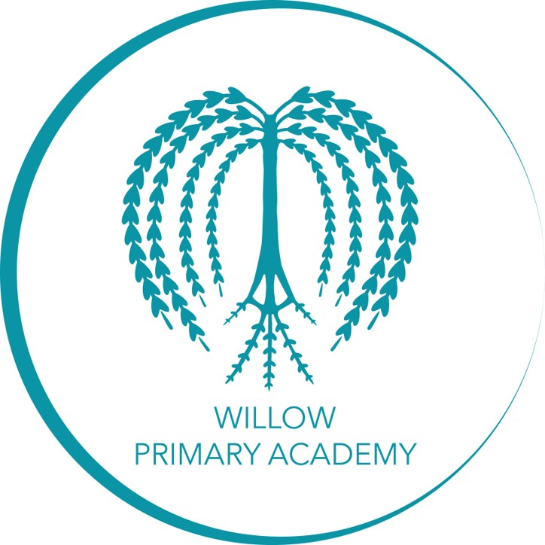

*“You can make anything by writing” –* ***C.S. Lewis***

|  |
| --- |
| **How we teach writing at Willow Primary Academy:** |
| At Willow Primary Academy we have a bespoke writing curriculum. In each term, from Year 1 to Year 6, there are units of narrative writing, non-fiction and some poetry. Each unit of writing primarily centres around high-quality picture books, film clips or novels that have been carefully chosen to include a range of genres, authors and themes and are selected to be progressive in their exposure to style, authorial choice and levels of maturity. Their selection has taken into account the needs, backgrounds and interests of our children, in order to build cultural capital.  The units of learning will follow the Planning Overview structures and Teaching Sequences. This is to ensure quality of teaching and consistency throughout the school. |
| **How planning looks at Willow Primary Academy:** |
| There is a writing long-term overview which outlines the core texts for writing.  There are termly overviews that show progression of skills across the terms/years and end points for each term. Green is already seen, Blue is new learning.  The units of work are mapped out by the teachers to ensure that prior learning is consolidated and new learning is introduced. Any gaps in pupils’ knowledge and skills are also included. The sequences of writing enable all pupils to engage with the texts, feel motivated to write and produce outcomes that show high standards and progress over time. Pupil write in a range of text types and genres during the year. |
| **How we teach grammar and punctuation at Willow.** |
| There is a short SPaG session daily in addition to the English lesson, which focuses on prior or current learning. These are marked by the pupils with teacher support. There is also a weekly SPaG quiz available, that also covers current and prior learning. The teacher decides which questions the children will complete, and how many depending on AfL from previous sessions.  Grammar and Punctuation is also embedded into the teaching sequences in all year groups. This will be explicitly linked to the unit of learning and will ensure that children apply prior learning and close any gaps before moving on to new content. The choice of grammatical features and vocabulary and the impact it has on the reader is covered throughout the writing unit, in order to develop pupils’ authorial choice as well as improve their fundamental sentence writing skills. |
| **How we teach Handwriting at Willow.** |
| At Willow Primary Academy, we have high expectations of presentation of pupils work in all subjects. We have our own policy and progression structure that we follow. Handwriting is taught daily in KS1 and at least twice a week in KS2. See policy and progression document. This is modelled explicitly throughout the curriculum all the time. In EYFS and at the beginning of Year 1, handwriting is predominantly taught through the RWInc scheme. |
| **How we teach spelling at Willow.** |
| Spelling, beginning early in EYFS, is taught through Read, Write, Inc (RWI) phonics sessions on a daily basis. This gives the children the opportunity to apply their learnt phoneme/grapheme correspondence to writing.  From Year 1 onwards, they practise rules weekly. This curriculum is progressive and allows children to apply their previously learnt phonics, whilst also being introduced to new spelling patterns and rules, alongside exceptions to these. Year groups follow the Planning Overview documents for the writing curriculum.  There is a separate spelling session for 10-15 minutes each day. On Monday, the new spelling rule is introduced and word list given. On Tuesday to Thursday, children rehearse their spellings in a variety of ways. On Friday, they are also tested on this week’s spelling, plus 5 additional spellings from previous weeks that the teacher has identified as needing to be revisited.  Phonology is taught first which includes phonemes and graphemes and the blending of these to make words.  Morphology, including the use of prefixes and suffixes, is also covered in the unit writing sequences and reading rocks sessions when opportunities arise and pupils’ knowledge of spelling patterns are developed over time.  Etymology is used during the spelling sessions when introducing the spelling patterns, and should be revised when appropriate in other reading and writing activities. |
| **How we assess writing at Willow.** |
| All teachers are expected to follow the school’s marking and feedback policy for writing.  All teachers will be constantly assessing writing, using AfL techniques, to ensure that they can plan for next steps, address misconceptions and fully-understand the current level of attainment of their class.  Pupils are continually supported in both peer and self-assessment using success criteria and supporting resources on the working wall.  In EYFS, baseline assessments identify skills and gaps. The EYFS curriculum is front loaded to address gaps in children’s physical development and early mark making so that children make rapid progress. The teachers will make observations on children’s writing and track progress right from early mark-making, up to writing sentences with capital letters and full stops. Immediate interventions will be put in place where a child is assessed as not meeting expectations. Teachers will report assessments onto Insight 3 times per year.  For the rest of the school, the teachers will use the assessing writing document to support their own judgements at the end of each term. Alongside this, pupils will complete a summative assessment for SPaG. The overall judgement is added to the Insight Tracking system. |
| **How we moderate writing at Willow.** |
| All teachers at Willow Primary Academy will receive CPD on effective use of moderation.  Moderation Point 1- End of Autumn Term: Agree what ARE looks like at this point in the year, what progress is expected from Moderation Point 1.  Moderation Point 2- End of Spring Term: Teachers to bring ‘on-the-cusp’ of ARE and GD for professional dialogue to avoid over-cautious or over-generous assessments.  External Moderation – June: Link with other schools to compare year group judgements  Moderation Point 3- End of Summer Term: In pairs, teachers decide how they would assess pieces of writing for WT-ARE, ARE and GD and then feedback on these, check against the teacher’s judgement made.  All moderation points will be used for whole-school reflection on quality of learning and next steps in developing writing in the school.  Teachers will come to the moderation sessions with a range of attainments (WTS, EXS and GD). They will then work in phases or with the teachers of the year groups above and below them to look at the judgements that have been made to clarify together or to challenge each other through professional dialogue. Using the Insight Tracking Data and the assessment grids to assess against Key Performance Indicators, linked to end-of-KS Assessment Frameworks, teachers will have confidence that the assessment judgements that they are making are accurate. |
| **Learning Environments** |
| All English displays must be backed using a pale blue with a dark blue border.  Learning environments must support the current learning for the children. Classrooms at Willow Primary Academy are designed by teachers to minimise ‘wallpaper’ displays that are not relevant, useful or referred to. Each classroom will have working walls for English that will scaffold and support the current unit of learning. They will act as a prompt to previous learning and will be used regularly by the adults and children in the classroom to enhance the learning.  The structure for each writing unit is represented by a pathway that is displayed and any supportive materials or writing examples are placed next to the corresponding step. These are built on in each lesson. The Purpose and Audience is also shown on an editable poster.  The success criteria will be written with the teacher and displayed on an editable poster too.  Washing Lines or displays may also show toolkits, ambitious vocabulary and SPaG outcomes that could support the pupils writing.  High-quality work that celebrates writing may be displayed in the classroom or in the corridors. |

**Teaching Sequences at Willow Academy:**

|  |  |  |  |  |  |
| --- | --- | --- | --- | --- | --- |
| **Reception** | **Monday** | **Tuesday** | **Wednesday** | **Thursday** | **Friday** |
| **Drawing Club – Greg Bottrill** | Vocabulary  Story share  Modelling drawing and 3’M’ing – Making conversation, mark making, mathematics (Monday – character focus, Tuesday – setting focus)  Drawing Club opportunities within provision | | Vocabulary  Modelling drawing and 3’M’ing – Making conversation, mark making, mathematics (adventure/solving a problem focus)  Drawing Club opportunities within provision | | |
| **Story scribing** | During provision, staff will model writing for a purpose. Staff will lead the writing process and will involve pupils at their level of development, focusing on their next steps. These stories will be shared with the class and acted out where appropriate. | | | | |

|  |  |  |  |  |  |  |  |
| --- | --- | --- | --- | --- | --- | --- | --- |
| **Year 1- 6** | **Ignite learning**  **Analyse text**  **Generate ideas**  *Know what a good one looks like, feels like and sounds like.* | **Write as a reader (whole class)**  **Ready, Steady, Go**  *Develop ideas further and use the tools and techniques to produce high-quality writing.*  *Direct instruction and modelling.*  *Children produce own draft.* | **Revise and proof read**  *Teach children to take a second, more general look at their writing.* | **Edit and Evaluate**  **E1, E2, E3**  *Teach children to look at whether they have expressed their ideas in an accurate and cohesive way.* | **Present/Perform**  *Children share work with the intended audience* |  | **Assessment Write (end of ‘big’terms)**  *Teacher guides a child(ren) and is their companion.*  *Children produce own written outcome.* |
|  | * Hook   **Read as a reader**   * SPACE (Structure, Purpose, Audience, Composition and Effect) * Use VIPERS/Book Talk * Discuss authorial choice * Analyse vocabulary choices, including technical and hidden meanings, e.g. the door was ajar, tell me I’m all ears etc * Drama/role play * Developing opinions and asking questions   **Explore as a writer**   * Focus on one good example * SPACE (including features) * Work backwards from success criteria * SPaG/input and practise based on success criteria and prior assessment * Mini writing tasks – may be used in main writing outcome * Build vocabulary choices | * Finalising and sequencing own ideas and content * Plan in brief on empty pathway/skeleton * Share plan confidently with a partner * Provide brief feedback on plans * Writing Pathway is displayed and revealed daily (some steps could take 2 lessons) * Teacher models forming a sentence using ‘thinking out loud’. Choices are explained and justified in relation to the effect on the reader. Accurate, high-level writing is modelled. * Teacher models writing ‘temporary spellings’ * Children orally rehearse and arrange their own ideas before committing to English book. * Modelled write, shared write, guided write and independent write (Slow write) | * SELF/PEER ASSESSMENT -Pupils re-read their writing to check if it fulfils SPACE. * SELF/PEER ASSESSMENT - Check against Success Criteria * SELF/PEER ASSESSMENT – Check punctuation and spelling * KS1 will follow RAP (revise, add, proof-read) | * Mark work prior to this session against success criteria and using marking codes (unless assessment piece) * Scaffold marking * Model correcting errors – use whole class feedback to address common errors * SELF/PEER ASSESSMENT - Missing words, spelling mistakes, grammatical mistakes, Missing/inaccurate punctuation | * May not always be ‘big’ hitting e.g., children reading aloud in class, displaying work, presenting to other classes, sending copies home to parents, posting on social media or website * Incentive for pupils to produce high quality writing | * Revisit key features from model texts and work together to create a writer’s toolkit (success criteria, SPACE) * Children create their own plan. * Children place ideas onto writing pathway. * Children write their own outcome. * On the spot, timely feedback is provided relating to success criteria. * Revisit any SPAG areas that need further input |

Writing genres guide

|  |  |  |  |
| --- | --- | --- | --- |
| **Year group** | **Fiction** | **Non-Fiction** | **Recount** |
| **1** | Short narrative – retelling orally  Story sentences – orally before written  Five-part story  Traditional tale  Character description  Setting description | Lists  Captions  Labels  Instructions  Information poster | Oral retelling – personal  Postcard  Short written recount of an event |
| **2** | Setting description  Character description  Extended story – retelling  Extended story – continuation of plot | Information Leaflet  Instructional writing  Non-Chronological report  Persuasive letter | Biography  Personal recount  Postcard |
| **3 / 4** | Setting description  Character description  Parts of stories – opening, ending, alternative plot  Extended stories – suspense, sequel, alternative viewpoint, adventure  Graphic novel  Playscript | Non-chronological report  Persuasive advert/blog/post  Instructional writing  Information leaflet  Holiday brochure  Explanation  Debate (oral) | Fictional recount – Diary  Factual recount (News report - speech)  Magazine article |
| **5 / 6** | Setting description including atmosphere  Character description including use of dialogue  Short story – first person, suspense, humour  Extended story – myth, additional chapter, alternative viewpoint, with flashback, mystery  Playscript  Traditional tale with a twist | Non-chronological report  Balanced argument  Instructional writing  Explanation  Persuasive speech/letter  Informal email/letter  Formal email/letter  Film/trailer review | Factual recount (Newspaper report)  Biography  Fictional recount - Diary  Blog |