Year 1 Autumn Term
Spelling | Handwriting |  | Punctuation | Grammar
- Words with ‘f’ and ‘s’ sound spelt ‘ff’ and ‘ss’  - Words with ‘l’, ‘k’ and ‘z’ sound spelt ‘ll’, ‘ck’ and ‘zz’  - Words with the suffixes ‘ing’, ‘ed’ and ‘er’  - Words with ‘ng’ and ‘nk’  - Words with ‘ch’ sound spelt ‘tch’  - Words with ‘v’ sound spelt ‘ve’  - Words with digraphs ‘ai’ and ‘oi’  - Words with digraphs ‘ay’ and ‘oy’  - Words with ‘oa’ sound spelt ‘oa, ‘ow’ and ‘oe’  - Words with ‘ee’ sound spelt with ‘e’ and ‘ee’  - Words with digraph ‘ea’  - Words with digraph ‘ie’ making ‘ie’ and ‘ee’ sound | - Sit correctly at a table, with a straight back and two feet flat on the floor.  - Form lower-case letters in the correct direction, starting and finishing in the right place  - Form digits 0-9  - Understand which letters belong to which handwriting ‘families’ (i.e. letters that are formed in similar ways) and to practise these.  - Use spacing between words that reflects the size of the letters |  | - Begin to punctuation sentences using a capital letter and full stop  - Use capital letters for names  - Use capital letters for the personal pronoun I | - Know how words combine to make sentences  - Join words using and  - Begin to use adjectives to modify nouns  - Know that suffixes can be added to verbs when no change is needed in the spelling of the root word (-ing, -er,- est)
Text for the Term: |  | Composition |  |  | Terminology
  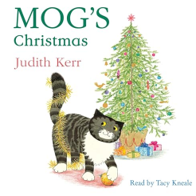 |  | Pupils should be taught to:  - Composing a sentence orally before writing it  - Re-reading what they have written to check that it makes sense  - Discuss what they have written with the teacher or other pupils  - Read aloud their writing clearly enough to be heard by their peers and the teacher |  |  | letter  capital letter  sentence  punctuation  full stop  exclamation mark  question mark  noun  adjective  prefix  verb  expanded noun phrase  conjunction  personal pronoun  imperative verb  plural / singular  suffix

Year 1 Spring Term
Spelling | Handwriting |  | Punctuation | Grammar
- Words with trigraph ‘igh’  - Words with digraph ‘ar’  - Words with digraph ‘er’  - Words with diagraph ‘ir’ and ‘ur’  - Words adding -er and -est to adjective where no change is needed to root word  - Days of the week and common exception words: there, here, they  - Words with ‘k’ sound spelt with ‘k’ before e, I and y  - Words with split digraph ‘a-e’ and ‘e-e’  - Words with split digraph ‘i-e’ and ‘o-e’  - Words with split digraph ‘u-e’  - Words with digraph ‘oo’  - Words with ‘ue’ and ‘ew’ | - Sit correctly at a table, with a straight back and two feet flat on the floor.  - Form lower-case letters in the correct direction, starting and finishing in the right place  - Form digits 0-9  - Understand which letters belong to which handwriting ‘families’ (i.e. letters that are formed in similar ways) and to practise these.  - Use spacing between words that reflects the size of the letters  - Form capital letters correctly – awareness for name and beginning of a sentence |  | - Begin to punctuation sentences using a capital letter and full stop  - Use capital letters for names  - Use capital letters for the personal pronoun I  - Use capital letters for days of the week  - Use capital letters for places  - Begin to use exclamation marks  - Begin to use question marks | Pupils should revise and be secure:  - Know how words combine to make sentences  Pupils should be taught to:  - Join words using ‘and’  - Begin to use adjectives to modify nouns  - Know that suffixes can be added to verbs when no change is needed in the spelling of the root word (-ing, -ed, -er,- est)  - Know regular plural noun suffixes -s or -es  - Join clauses using and
Texts for the Term |  | Composition |  |  | Terminology
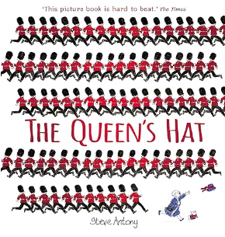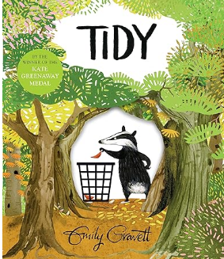  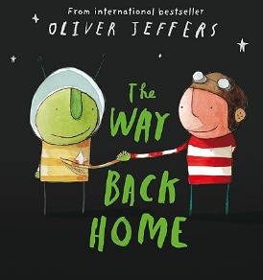 |  | - Composing a sentence orally before writing it  - Re-reading what they have written to check that it makes sense  - Discuss what they have written with the teacher or other pupils  - Read aloud their writing clearly enough to be heard by their peers and the teacher  - Understand that words can join to form sentences and write simple and compound sentences, which can be read by themselves and others |  |  | letter  capital letter  sentence  punctuation  full stop  exclamation mark  question mark  noun  adjective  prefix  verb  expanded noun phrase  conjunction  personal pronoun  imperative verb  plural / singular  suffix

Spelling | Handwriting | Punctuation |  | Grammar
- Words with digraph ‘ow’ and ‘ou’  - Words ending in ‘ee’ sound spelt with ‘y’  - Words with ‘or’ and ‘ore’  - Words with ‘aw’ and ‘au’  - Words with ‘air’ and ‘are’  - Words with ‘ear’  - Words with ‘ph’ and ‘wh’  - Words with prefix ‘un’  - Words with plurals ‘s’ and ‘es’  - Compound words  - Contractions  - Common exception words: of, said, was has, come, one, once, ask, your, is | - Sit correctly at a table, with a straight back and two feet flat on the floor. Paper slightly slanted.  - Form lower-case letters in the correct direction, starting and finishing in the right place  - Form capital letters correctly – awareness for name and beginning of a sentence  - Form digits 0-9  - Understand which letters belong to which handwriting ‘families’ (i.e. letters that are formed in similar ways) and to practise these.  - Use spacing between words that reflects the size of the letters | - Begin to punctuation sentences using a capital letter and full stop  - Begin to use exclamation marks  - Begin to use question marks  - Use capital letters for names  - Use capital letters for the personal pronoun I  - Use capital letters for days of the week  - Use capital letters for places |  | - Know how words combine to make sentences  - Join words using and  - Join clauses using and  - Begin to use adjectives to modify nouns  - Know regular plural noun suffixes -s or -es  - Know that suffixes can be added to verbs when no change is needed in the spelling of the root word (-ing, -ed, -er, -est)  - Begin to use some of the distinctive features of Standard English in their writing  - Begin to use present and past tense correctly  - Know how a prefix un changes the meaning of verbs and adjectives  - Know and use a range of nouns and adjectives
Texts for the Term |  |  | Composition |  | Terminology
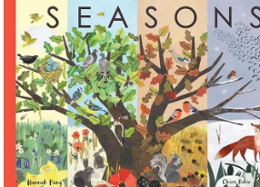 |  |  | - Composing a sentence orally before writing it  - Re-reading what they have written to check that it makes sense  - Discuss what they have written with the teacher or other pupils  - Read aloud their writing clearly enough to be heard by their peers and the teacher  - Sequence sentences to form short narratives  - Understand that words can join to form sentences and write simple and compound sentences, which can be read by themselves and others  - Sequencing sentences to form short narratives  - Encourage pupils to think out loud as they collect their ideas for writing encourage pupils to draft, re-read and check their meaning is clear |  | letter  capital letter  sentence  punctuation  full stop  exclamation mark  question mark  noun  adjective  prefix  verb  expanded noun phrase  conjunction  personal pronoun  imperative verb  plural / singular  suffix
Year 1 Summer Term

