Year 2 Autumn

Spelling | Handwriting |  | Punctuation | Grammar
Pupils should be taught to spell:  - Words where ‘kn’ and ‘gn’ make a /n/ sound at the beginning of words  - Words where ‘wr’ makes a /r/ sound at the beginning of words  - Words where ‘c’ makes a /s/ sound before ‘e’, ‘i’ and ‘y’  - Words where ‘dge’ and ‘ge’ makes a /j/ sound  - Words where ‘g’ makes a /j/ sound  - Common exception words: door, floor, again, wild, children, climb, parents, most only, both  - Words ending in ‘le’  - Words ending in ‘el’  - Words ending in ‘al’ and ‘il’  - Words where ‘y’ makes an /igh/ sound  - Words where ‘-ies’ is added to words ending in ‘y’  - Common exception words: find, mind, behind, old, cold, gold, hold, told, every, everybody, Christmas | - Use spacing between words that reflects the size of the letters  - Form lower case letters of the correct size relative to one another  - Use some of the diagonal and horizontal strokes used to join letters  - Understand which letters are best left unjoined  - Write capital letters and digits of the correct size, orientation and relationship to one another and to lower case letters |  | - Use familiar punctuation correctly including full stops, capital letters (including proper nouns and pronoun ‘I’), exclamation marks and question marks  - Use commas to punctuation expanded noun phrases | - Begin to use some of the distinctive features of Standard English in their writing  - Know that suffixes can be added to verbs where a change is needed to a root word  - Use sentences with different forms: statement, question, command, exclamation  - Use suffixes -er and -est in adjectives  - Know how a prefix un changes the meaning of verbs and adjectives  - Expanded noun phrases to describe and specify  - Use the present and past tenses correctly and consistently, including the progressive form  - Use co-ordination (or, and or but)  - Know that some nouns are formed by compounding
Texts for the Term |  | Composition |  |  | Terminology
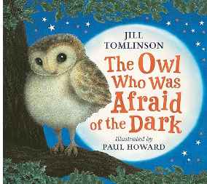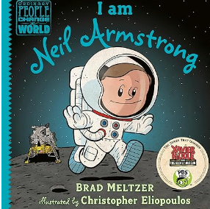  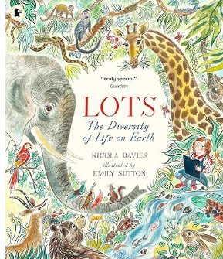 |  | - Sequencing sentences to form short narratives  - Discuss what they have written with the teacher or other pupils  - Encourage pupils to think out loud as they collect their ideas for writing encourage pupils to draft, re-read and check their meaning is clear  - Plan what they are going to write about  - Develop their ideas through drama and role-play  - Encapsulate what they want to say sentence by sentence  - Write down ideas or key words, including new vocabulary  - Re-read own writing to check that their writing makes sense and that verbs to indicate time are used consistently and correctly  - Proof-read to check for errors in spelling, grammar and punctuation  - Select and use appropriate registers for effective communication  - Read aloud what they have written with appropriate intonation to make the meaning clear |  |  | capital letter  punctuation  full stop  exclamation mark  question mark  noun  adjective  verb  expanded noun phrase  noun phrase  subordination  co-ordination  present tense  past tense  similes  statement  comma | question  command  exclamation  genre  third person  first person  conjunction  personal pronoun  imperative verb  plural / singular  suffix  apostrophe  Standard English  comma  adverb  time conjunctions  fact  opinion  synonyms  dialogue

Year 2 Spring
Spelling | Handwriting | Punctuation | Grammar
- Words where ‘-ed’, ‘er’ or ‘est’ is added to words ending in ‘y’  - Words where ‘-ing’ is added to words ending in ‘y  - Words where ‘ing’, ‘ed’, ‘er’, ‘est’ and ‘y’ are added to words ending in e with a consonant before it.  - Words where ‘-ing, ‘ed’, ‘er’, ‘est’ and ‘y’ are added to single syllable words  - Words where ‘a’ makes an /or/ sound before ‘l’ or ‘ll’.  - Common exception words: fast, last, father, class, grass, pass, plant, path, bath, people  - Words where ‘o’ makes an /u/ sound  - Words where the digraph ‘ey’ makes an /ee/ sound  - Words where ‘a’ makes an /o/ sound after w or qu.  - Words where ‘or’ and ‘ar’ make an /er/ or /or/ sound  - Words where ‘si’ and ‘s’ makes an /zh/ sound  - Common exception words: even, break, steak, great, move, prove, improve, sure, sugar, eye | - Use some of the diagonal and horizontal strokes used to join letters  - Understand which letters are best left unjoined  - Write capital letters and digits of the correct size, orientation and relationship to one another and to lower case letters | - Use familiar punctuation correctly including full stops, capital letters (including proper nouns and pronoun ‘I’), exclamation marks and question marks  - Use commas to punctuation expanded noun phrases  - Use commas to separate items in a list | - Know that suffixes can be added to verbs where a change is needed to a root word  - Use sentences with different forms: statement, question, command, exclamation  - Use suffixes -er and -est in adjectives  - Know how a prefix un changes the meaning of verbs and adjectives  - Expanded noun phrases to describe and specify  - Use the present and past tenses correctly and consistently, including the progressive form  - Use co-ordination (or, and or but)  - Know that some nouns are formed by compounding  - Use some features of written Standard English  - Form adjectives using suffixes such as -ful, -less  - Use -ly in Standard English to turn adjectives into adverbs  - Form noun using suffixes such as -ness  - Use subordination (using when, if, that or because)
Texts for the Term |  | Composition |  | Terminology
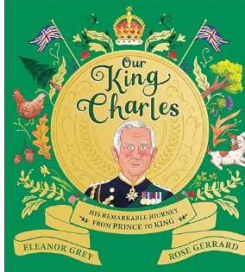  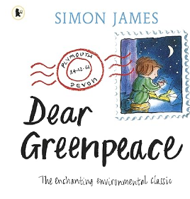 |  | - Develop positive attitudes towards and stamina for writing  - Plan or say out loud what they are going to write about  - Encapsulate what they want to say sentence by sentence  - Write down ideas or key words, including new vocabulary  - Re-read own writing to check that their writing makes sense and that verbs to indicate time are used consistently and correctly  - Develop their ideas through drama and role-play  - Read aloud what they have written with appropriate intonation to make the meaning clear  - Write a narrative about personal experiences and those of others  - Write poetry  - Write for different purposes  - Proof-read to check for errors in spelling, grammar and punctuation  - Gain, maintain and the interest of the listeners  - Evaluate their writing with the teacher and other peers |  | capital letter  punctuation  full stop  exclamation mark  question mark  noun  adjective  verb  expanded noun phrase  noun phrase  subordination  co-ordination  present tense  past tense  similes  statement  comma | question  command  exclamation  genre  third person  first person  conjunction  personal pronoun  imperative verb  plural / singular  suffix  apostrophe  Standard English  comma  adverb  time conjunctions  fact  opinion  synonyms  dialogue
Year 2 Summer

Spelling | Handwriting | Punctuation |  | Grammar
- Words ending in ‘-ment’, ‘ful’ and ‘-ness’  - Words ending in ‘-ly’ and ‘-less’  - Words ending in ‘-tion’  - Contractions  - Possessive apostrophe  - Common exception words: any, many, clothes, water, pretty, Christmas, beautiful, busy, poor, kind  - Words that are homophones  or near homophones  - Conjunctions  - Months of the year  - Time words  - Question words  - SPAG terms | - Use some of the diagonal and horizontal strokes used to join letters  - Understand which letters are best left un-joined  - Write capital letters and digits of the correct size, orientation and relationship to one another and to lower case letters | - Use familiar punctuation correctly including full stops, capital letters (including proper nouns and pronoun ‘I’), exclamation marks and question marks  - Use commas to punctuation expanded noun phrases  - Use commas to separate items in a list  - Use apostrophes to mark where letters are missing in spelling and to mark singular possession in nouns |  | - Know that suffixes can be added to verbs where a change is needed to a root word  - Use sentences with different forms: statement, question, command, exclamation  - Use some features of written Standard English  - Form adjectives using suffixes such as -ful, -less  - Form noun using suffixes such as -ness  - Use suffixes -er and -est in adjectives  - Use -ly in Standard English to turn adjectives into adverbs  - Know how a prefix un changes the meaning of verbs and adjectives  - Expanded noun phrases to describe and specify  - Use the present and past tenses correctly and consistently, including the progressive form  - Use subordination (using when, if, that or because) and co-ordination (or, and or but)  - Know that some nouns are formed by compounding
Texts for the Term |  |  | Composition |  | Terminology
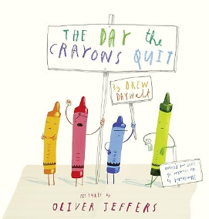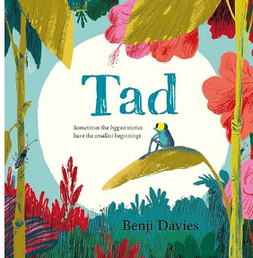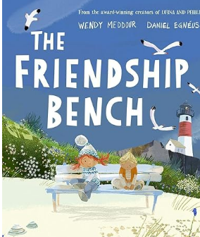 |  |  | - Develop positive attitudes towards and stamina for writing  - Plan or say out loud what they are going to write about  - Encapsulate what they want to say sentence by sentence  - Write down ideas or key words, including new vocabulary  - Re-read own writing to check that their writing makes sense and that verbs to indicate time are used consistently and correctly  - Read aloud what they have written with appropriate intonation to make the meaning clear  - Write a narrative about personal experiences and those of others  - Write for different purposes  - Proof-read to check for errors in spelling, grammar and punctuation  - Gain, maintain and the interest of the listeners  - Evaluate their writing with the teacher and other peers  - Develop their ideas through drama and role-play |  | capital letter  punctuation  full stop  exclamation mark  question mark  noun  adjective  verb  expanded noun phrase  noun phrase  subordination  co-ordination  present tense  past tense  similes  statement  comma | question  command  exclamation  genre  third person  first person  conjunction  personal pronoun  imperative verb  plural / singular  suffix  apostrophe  Standard English  comma  adverb  time conjunctions  fact  opinion  synonyms  dialogue

