Year 3 Autumn

Spelling | Handwriting |  | Punctuation | Grammar
- Words with the digraph ‘ei’ and tetragraph ‘eigh’  - Words where the digraph ‘ey’ makes an /ai/ sound  - Words with the digraph ‘ai’  - Words with ‘ear’ making ‘ur’ sound.  - Words that are homophones and near homophones.  - Words ending in ‘ly’ with no change to root word  - Words ending in ‘-ly’ where the base word ends in ‘y’  - Words ending in ‘-ly’ where the base word ends in ‘le’  - Words ending in ‘-ly’ where the base word ends in ‘-ic’ or ‘al’  - Words ending in ‘-ly’ – exceptions to the rules.  - Words from spelling list: believe, appear, often, group, breath, continue, arrive, women, describe, height | - Write capital letters and digits of the correct size, orientation and relationship to one another and to lower case letters  - Use the diagonal and horizontal strokes used to join letters  - Understand which letters are best left unjoined |  | - Use familiar punctuation correctly including full stops, capital letters (including proper nouns and pronoun ‘I’), exclamation marks and question marks  - Use apostrophes to mark where letters are missing in spelling and to mark singular possession in nouns  - Use commas to punctuation expanded noun phrases and separate items in a list  - Use organisational devices to structure writing e.g. bullet points and sub-headings | - Use sentences with different forms: statement, question, command, exclamation  - Use some features of written Standard English  - Expanded noun phrases to describe and specify  - Use the present and past tenses correctly and consistently, including the progressive form  - Use subordination (using when, if, that or because) and co-ordination (or, and or but)  - Use appropriate choice of pronoun or noun within and across sentences to aid cohesion and avoid repetition
Texts this term |  | Composition |  | Terminology
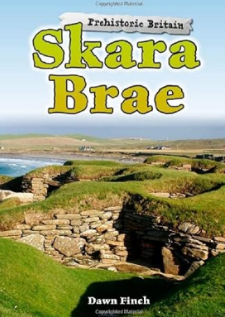  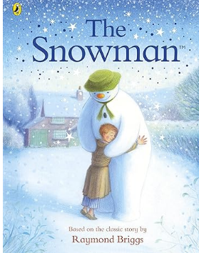 |  | - Develop their ideas through drama and role-play  - Plan their writing by discussing and recording ideas  - Draft and write by organising simple paragraphs around a theme.  - Draft and write by creating simple setting, characters and a basic plot in a narrative.  - Use headings and sub-headings to aid presentation  - Compose and rehearse sentences orally (including dialogue), progressively building a varied and rich vocabulary  - Compose and rehearse sentences orally increasing the range of sentence structures  - Evaluate and edit by proposing changes to grammar and vocabulary to improve consistency  - Proof read for spelling and punctuation errors  - Evaluate and edit by assessing the effectiveness of their own and others writing and suggesting improvements  - Read aloud their own writing using appropriate intonation and controlling the tone and volume so that the meaning is clear |  | subordination  co-ordination  similes  genre  third person  first person  personal pronoun  suffix  apostrophe  Standard English  adverb  fact  opinion  synonyms  dialogue  conjunction  metaphor  personification  bullet points  inverted commas  time adverbials/conjunctions  paragraph | reporting clause  preposition  clause  subordinate clause  main clause formal  informal  rhetorical questions  headings  sub-headings  rhyme  emotive language  persuasive language  consonant  vowel  intensifiers  objective  subjective  alliteration  prefix

Year 3 Spring
Spelling | Handwriting |  | Punctuation | Grammar
- Words where ‘y’ makes an /i/ sound  - Words where ‘-ing’, ‘-er’, -est, -y and ‘-ed’ are added to multisyllabic words – non doubling consonant.  - Words where ‘-ing’, ‘-er’, -est, -y and and ‘-ed’ are added to multisyllabic words – doubling consonant.  - Words with the prefix ’mis-’  - Words with the prefix ’dis-’  - Words when ‘ch’ makes ‘k’ sound  - Words that are homophones or near homophones  - Words with the prefix ’re-  - Words with the prefix ‘bi’.  - Words ending in ‘-gue’ and ‘-que’  - Words when ‘ch’ makes ‘sh’ sound  - Word from spelling list: address, busy, business, heart, fruit, breathe, strange, complete, extreme, forwards | - Use the diagonal and horizontal strokes used to join letters  - Understand which letters are best left unjoined  - Increase the legibility, consistency and quality of their handwriting e.g. by ensuring that the downstrokes of letters are parallel and equidistant; lines of writing are spaced sufficiently so that the ascenders and descenders of letters do not touch |  | - Use familiar punctuation correctly including full stops, capital letters (including proper nouns and pronoun ‘I’), exclamation marks and question marks  - Use apostrophes to mark where letters are missing in spelling and to mark singular possession in nouns  - Use commas to punctuation expanded noun phrases and separate items in a list  - Use organisational devices to structure writing e.g. bullet points and sub-headings  - Begin to use inverted commas to punctuate direct speech | - Expanded noun phrases to describe and specify  - Use the present and past tenses correctly and consistently, including the progressive form  - Use subordination (using when, if, that or because) and co-ordination (or, and or but)  - Use appropriate choice of pronoun or noun within and across sentences to aid cohesion and avoid repetition  - Express time, place and cause using conjunctions, adverbs and prepositions  - Use the forms of ‘an or a’ according to whether the next words begins with a consonant or vowel
Texts for the Term |  | Composition |  |  | Terminology
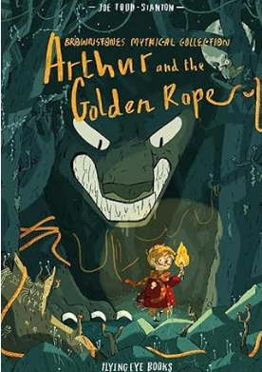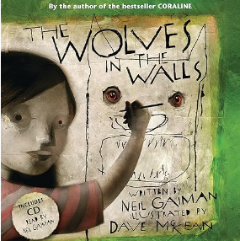  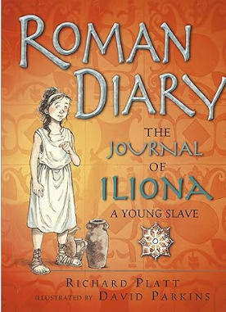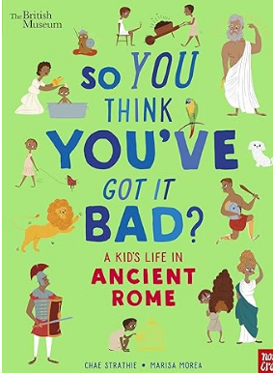 |  | - Develop their ideas through drama and role-play  - Plan their writing by discussing and recording ideas  - Draft and write by organising simple paragraphs around a theme.  - Draft and write by creating simple setting, characters and a basic plot in a narrative.  - Use headings and sub-headings to aid presentation  - Compose and rehearse sentences orally (including dialogue), progressively building a varied and rich vocabulary  - Compose and rehearse sentences orally increasing the range of sentence structures  - Evaluate and edit by proposing changes to grammar and vocabulary to improve consistency  - Proof read for spelling and punctuation errors  - Evaluate and edit by assessing the effectiveness of their own and others writing and suggesting improvements  - Read aloud their own writing using appropriate intonation and controlling the tone and volume so that the meaning is clear  - In narrative, begin to use paragraphs as a way to group related material |  |  | subordination  co-ordination  similes  genre  third person  first person  personal pronoun  suffix  apostrophe  Standard English  adverb  fact  opinion  synonyms  dialogue  conjunction  metaphor  personification  bullet points  inverted commas  time adverbials/conjunctions  paragraph | reporting clause  preposition  clause  subordinate clause  main clause formal  informal  rhetorical questions  headings  sub-headings  rhyme  emotive language  persuasive language  consonant  vowel  intensifiers  objective  subjective  alliteration  prefix

Year 3 Summer
Spelling | Handwriting | Punctuation |  | Grammar
- Words ending in ‘ary’.  - Words with short ‘u’ sound spelt with ‘o’.  - Words where the digraph ‘ou’ makes a /u/ sound  - Word families based on common words showing relation in meaning.  - Words ending in suffix ‘-al’.  - Words ending in ‘-sure’  - Words ending in ‘-ture’  - Silent letter revision words: island, answer, write, wrapper, knife, knock, thumb, doubt, half, calm  - Silent letter revision words: build, guide, guard, wheat, whale, honest, whirl, gnome, gnaw, surprise | - Use the diagonal and horizontal strokes used to join letters  - Understand which letters are best left unjoined  - Increase the legibility, consistency and quality of their handwriting e.g. by ensuring that the downstrokes of letters are parallel and equidistant; lines of writing are spaced sufficiently so that the ascenders and descenders of letters do not touch | - Use familiar punctuation correctly including full stops, capital letters (including proper nouns and pronoun ‘I’), exclamation marks and question marks  - Use apostrophes to mark where letters are missing in spelling and to mark singular possession in nouns  - Use commas to punctuation expanded noun phrases and separate items in a list  - Use organisational devices to structure writing e.g. bullet points and sub-headings  - Begin to use inverted commas to punctuate direct speech  - Begin to use question marks and exclamation marks appropriately within direct speech |  | - Expanded noun phrases to describe and specify  - Use the present and past tenses correctly and consistently, including the progressive form  - Use subordination (using when, if, that or because) and co-ordination (or, and or but)  - Express time, place and cause using conjunctions, adverbs and prepositions  - Use the forms of ‘an or a’ according to whether the next words begins with a consonant or vowel  - Use appropriate choice of pronoun or noun within and across sentences to aid cohesion and avoid repetition  - Know that word families are based on common words, showing how words are related in form and meaning e.g. solve, solution, solver, dissolve  - Extend the range of sentences with more than one clause by using a wider range of conjunctions  - Begin to vary the position of subordinating clauses
Texts for the Term |  |  | Composition |  | Terminology
   |  |  | - Develop their ideas through drama and role-play  - Plan their writing by discussing and recording ideas  - Draft and write by organising simple paragraphs around a theme.  - Draft and write by creating simple setting, characters and a basic plot in a narrative.  - Use headings and sub-headings to aid presentation  - In narrative, begin to use paragraphs as a way to group related material  - Compose and rehearse sentences orally (including dialogue), progressively building a varied and rich vocabulary  - Compose and rehearse sentences orally increasing the range of sentence structures  - Evaluate and edit by proposing changes to grammar and vocabulary to improve consistency  - Proof read for spelling and punctuation errors  - Evaluate and edit by assessing the effectiveness of their own and others writing and suggesting improvements  - Read aloud their own writing using appropriate intonation and controlling the tone and volume so that the meaning is clear |  | subordination  co-ordination  similes  genre  third person  first person  personal pronoun  suffix  apostrophe  Standard English  adverb  fact  opinion  synonyms  dialogue  conjunction  metaphor  personification  bullet points  inverted commas  time adverbials/conjunctions  paragraph | reporting clause  preposition  clause  subordinate clause  main clause  formal  informal  rhetorical questions  headings  sub-headings  rhyme  emotive language  persuasive language  consonant  vowel  intensifiers  objective  subjective  alliteration  prefix

