Year 4 Autumn
Spelling | Handwriting | Punctuation |  | Grammar
Pupils should be taught to spell:  - Words with ‘aw’ spelt with augh or au.  - Words with the prefix ’in-’ meaning ‘not’  - Words with the prefix ‘im-‘ before a root word starting with m or p  - Words with the prefixes ’il-’ and ‘ir-’  - Words that are homophones  - Words ending in ’-sion’  - Words ending in ‘-ssion.  - Words ending in –‘tion’  - Words ending in ‘-cian’  - Word with ‘ough’ making long o, oo, o sound | - Increase the legibility, consistency and quality of their handwriting e.g. by ensuring that the downstrokes of letters are parallel and equidistant; lines of writing are spaced sufficiently so that the ascenders and descenders of letters do not touch | - Use commas to punctuation expanded noun phrases and separate items in a list  - Use organisational devices to structure writing e.g. bullet points and sub-headings  - Use apostrophes to mark where letters are missing in spelling and to mark singular possession in nouns  - Use commas after fronted adverbials |  | - Express time, manner, place and cause using conjunctions, adverbs and prepositions  - Use the forms of ‘an or a’ according to whether the next words begins with a consonant or vowel  - Use fronted adverbials correctly  - Use Standard English forms for verbs inflections instead of local forms e.g we were not we was  - Use noun phrases expanded by the addition of modifying adjectives  - Choose pronouns or nouns within and across sentences to aid cohesion and avoid repetition  - Use the present tense correctly  - Use past tense correctly, including both the present perfect form of verbs, in contrast to the simple past tense  - Write a range of sentences with more than one clause by using subordination and co-ordination
Texts for the Term |  |  | Composition |  | Terminology
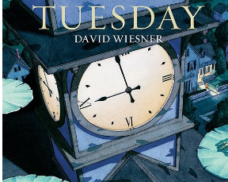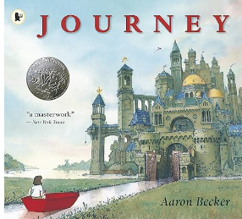  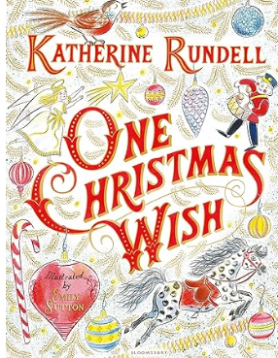 |  |  | - Compose and rehearse sentences orally (including dialogue), progressively building a varied and rich vocabulary  - Compose and rehearse sentences orally increasing the range of sentence structures  - Draft and write by organising paragraphs around a theme.  - Draft and write by creating settings, characters and plot in narratives.  - Draft and write using simple organisational devices in non-narrative, e.g. headings and subheadings.  - Read aloud their own writing using appropriate intonation and controlling the tone and volume so that the meaning is clear  - Evaluate and edit by proposing changes to grammar and vocabulary to improve consistency  - Proof read for spelling and punctuation errors  - Evaluate and edit by assessing the effectiveness of their own and others writing and suggesting improvements  - Plan their writing by discussing and recording ideas  - In narrative, use paragraphs as a way to group related material |  | subordination  co-ordination  third person  first person  personal pronoun  Standard English  synonyms  dialogue  conjunction  inverted commas  time adverbials/conjunctions  paragraph  reporting clause  preposition  clause  subordinate clause  main clause | formal  informal  rhetorical questions  headings  sub-headings  emotive language  persuasive language  consonant  vowel  fronted adverbial  direct speech  reported speech  figurative language  similes  metaphors  prefix  regular  irregular verbs  possessive apostrophe

Year 4 Spring
Spelling | Handwriting | Punctuation |  | Grammar
Pupils should be taught spell:  - Words that are homophones or near homophones  - Words with suffix -ation  - Words with prefixes ‘sub-‘ meaning under and ‘super’ meaning above  - Plural words with plural possessive apostrophes  - Words with ‘sc’ to make s sound.  - Words with soft c spelt with ‘ce’  - Words with soft c spelt ‘ci’  - Word families based on common words showing how words are related in form and meaning  - Words from the spelling list: length, strength, purpose, history, different, difficult, separate, suppose, therefore, knowledge | - Increase the legibility, consistency and quality of their handwriting e.g. by ensuring that the downstrokes of letters are parallel and equidistant; lines of writing are spaced sufficiently so that the ascenders and descenders of letters do not touch | - Use commas to punctuation expanded noun phrases and separate items in a list  - Use organisational devices to structure writing e.g. bullet points and sub-headings  - Use commas after fronted adverbials  - Use apostrophes to mark where letters are missing in spelling and to mark singular possession in nouns  - Use inverted commas and other punctuation to indicate direct speech |  | - Express time, manner, place and cause using conjunctions, adverbs and prepositions  - Use the forms of ‘an or a’ according to whether the next words begins with a consonant or vowel  - Use fronted adverbials correctly  - Use Standard English forms for verbs inflections instead of local forms e.g we were not we was  - Use noun phrases expanded by the addition of modifying adjectives  - Use noun phrases expanded by the addition of prepositional phrases  - Extend the range of sentences with more than one clause by using a wider range of conjunctions  - Choose pronouns or nouns within and across sentences to aid cohesion and avoid repetition  - Use the present tense correctly  - Use past tense correctly, including both the present perfect form of verbs, in contrast to the simple past tense  - Write a range of sentences with more than one clause by using subordination and co-ordination
Texts for the Term |  |  | Composition |  | Terminology
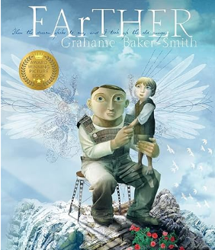  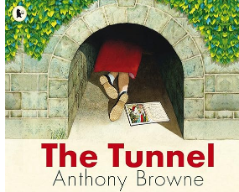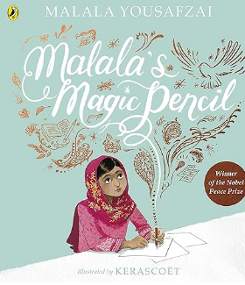 |  |  | - Compose and rehearse sentences orally (including dialogue), progressively building a varied and rich vocabulary  - Compose and rehearse sentences orally increasing the range of sentence structures  - Draft and write by organising paragraphs around a theme.  - Draft and write by creating settings, characters and plot in narratives.  - Draft and write using simple organisational devices in non-narrative, e.g. headings and subheadings.  - Read aloud their own writing using appropriate intonation and controlling the tone and volume so that the meaning is clear  - Evaluate and edit by proposing changes to grammar and vocabulary to improve consistency  - Proof read for spelling and punctuation errors  - Evaluate and edit by assessing the effectiveness of their own and others writing and suggesting improvements  - Plan their writing by discussing and recording ideas  - In narrative, use paragraphs as a way to group related material |  | subordination  co-ordination  third person  first person  personal pronoun  Standard English  synonyms  dialogue  conjunction  inverted commas  time adverbials/conjunctions  paragraph  reporting clause  preposition  clause  subordinate clause  main clause | formal  informal  rhetorical questions  headings  sub-headings  emotive language  persuasive language  consonant  vowel  fronted adverbial  direct speech  reported speech  figurative language  similes  metaphors  prefix  regular  irregular verbs  possessive apostrophe

Spelling | Handwriting |  | Punctuation | Grammar
- Words with prefix ‘inter’ meaning between or among  - Words with prefix ‘anti-‘meaning against  - Words with prefix ‘auto-‘meaning self or own  - Words with prefix ‘ex-‘meaning out  - Words with prefix ‘non’ meaning not  - Words ending in -ar or -er  - Words with suffix ’-ous’ with no change to root word  - Words with suffix ‘-ous’ with no root word  - Words with suffix ‘-ous’ with root words ending in y or our  - Words with suffix ‘-ous’ where root word e is dropped.  - Adverbials of frequency  - Adverbials of manner | - Increase the legibility, consistency and quality of their handwriting e.g. by ensuring that the downstrokes of letters are parallel and equidistant; lines of writing are spaced sufficiently so that the ascenders and descenders of letters do not touch |  | - Use commas to punctuation expanded noun phrases and separate items in a list  - Use organisational devices to structure writing e.g. bullet points and sub-headings  - Use commas after fronted adverbials  - Use apostrophes to mark where letters are missing in spelling and to mark singular possession in nouns  - Use inverted commas and other punctuation to indicate direct speech  - Indicate possession by using the possessive apostrophe with plural nouns | - Express time, manner, place and cause using conjunctions, adverbs and prepositions  - Use the forms of ‘an or a’ according to whether the next words begins with a consonant or vowel  - Use fronted adverbials correctly  - Use Standard English forms for verbs inflections instead of local forms e.g we were not we was  - Use noun phrases expanded by the addition of modifying adjectives  - Choose pronouns or nouns within and across sentences to aid cohesion and avoid repetition  - Use the present tense correctly  - Use past tense correctly, including both the present perfect form of verbs, in contrast to the simple past tense  - Write a range of sentences with more than one clause by using subordination and co-ordination  - Use noun phrases expanded by the addition of prepositional phrases  - Extend the range of sentences with more than one clause by using a wider range of conjunctions  - Know the grammatical difference between plural and possessive plural s
Texts for the Term |  | Composition |  |  | Terminology
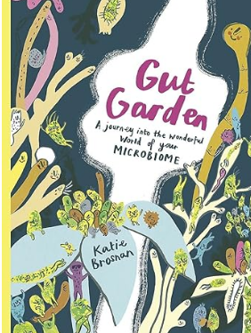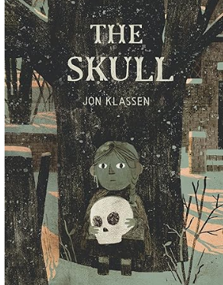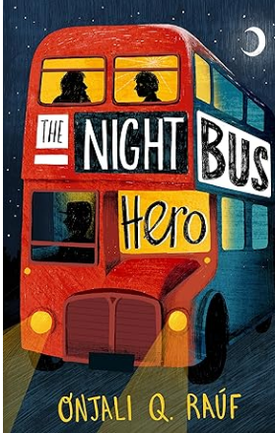 |  | - Compose and rehearse sentences orally (including dialogue), progressively building a varied and rich vocabulary  - Compose and rehearse sentences orally increasing the range of sentence structures  - Draft and write by organising paragraphs around a theme.  - Draft and write by creating settings, characters and plot in narratives.  - Draft and write using simple organisational devices in non-narrative, e.g. headings and subheadings.  - Read aloud their own writing using appropriate intonation and controlling the tone and volume so that the meaning is clear  - Evaluate and edit by proposing changes to grammar and vocabulary to improve consistency  - Proof read for spelling and punctuation errors  - Evaluate and edit by assessing the effectiveness of their own and others writing and suggesting improvements  - Plan their writing by discussing and recording ideas  - In narrative, use paragraphs as a way to group related material |  |  | subordination  co-ordination  third person  first person  personal pronoun  Standard English  synonyms  dialogue  conjunction  inverted commas  time adverbials/conjunctions  paragraph  reporting clause  preposition  clause  subordinate clause  main clause | formal  informal  rhetorical questions  headings  sub-headings  emotive language  persuasive language  consonant  vowel  fronted adverbial  direct speech  reported speech  figurative language  similes  metaphors  prefix  regular  irregular verbs  possessive apostrophe
Year 4 Summer

