Spelling | Handwriting | Punctuation | Grammar
Pupils should be taught to spell:  - Words ending in ‘-cious’  - Words ending in ‘-tious’ and ‘-ious’  - Words with short vowel ‘I’ sound spelt with ‘y’  - Words with long vowel ‘I’ sound spelt with ‘y’  - Words that are homophones or near homophones  - Words with silent letter  - Modal verbs  - Words ending in ‘ment’  - Adverbs of possibility and frequency  - Words from the spelling list: vegetable, vehicle, bruise, soldier, stomach, recommend, leisure, privilege, occur, neighbour | - Write legibly, fluently and with increasing speed by: choosing which shape of a letter to use when given choices, and deciding which letters to join; and choosing the writing implement best suited to the task | - Use commas after fronted adverbials  - Use inverted commas and other punctuation to indicate direct speech  - Indicate possession by using the possessive apostrophe with plural nouns  - Use commas to clarify meaning or avoid ambiguity | - Use Standard English forms for verbs inflections instead of local forms e.g. we were not we was  - Use noun phrases expanded by the addition of modifying adjectives, nouns and preposition phrases  - Extend the range of sentences with more than one clause by using a wider range of conjunctions  - Understand how words are related by meaning as synonyms and antonyms, and use a thesaurus to such for suitable synonyms.  - Know that difference between vocabulary typical of informal speech and vocabulary appropriate for formal speech and writing.  - Use present perfect forms of verbs.  - Use devices to build cohesion with a paragraph e.g. then, after that, this
Text for the Term |  | Composition |  | Terminology
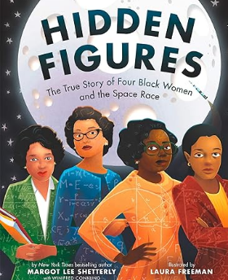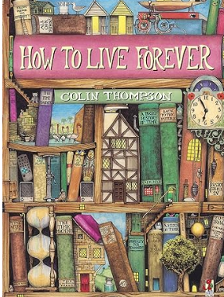  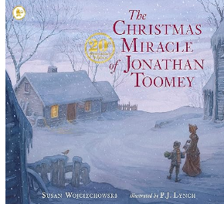 |  | - Compose and rehearse sentences orally (including dialogue), progressively building a varied and rich vocabulary and increasing the range of sentence structures.  - Plan their writing by identifying the audience for and purpose of the writing, selecting the appropriate form and using other similar writing as models for their own  - Note and develop initial ideas, drawing on reading and research where necessary  - Consider how authors have developed characters and settings.  - Draft and write by beginning to describe settings, characters and atmosphere and integrating dialogue to convey character and advance the action in narratives.  - Draft and write by beginning to select appropriate grammar and vocabulary, understanding how such choices can change and enhance meaning.  - Evaluate and edit by assessing the effectiveness of their own and others writing  - Edit by proposing changes to vocabulary, punctuation and grammar to enhance effects and clarify meaning  - Proof read for spelling and punctuation errors  - Perform their own compositions using appropriate intonation, volume and movement so that meaning is clear |  | Standard English  synonyms  inverted commas  time adverbials/conjunctions  reporting clause  preposition  subordinate clause  main clause  rhetorical questions  emotive language  direct speech  reported speech  figurative language  possessive apostrophe  comma  informal  formal  modal verbs  relative clauses  organisational device | tone  tension  suspense  mood  atmosphere  imagery  pathetic fallacy  opinion  hyphen  rhyming couplets  kenning  stanza  bracket  dash  parenthesis  lipogram  diamante  symbolism
Year 5 Autumn

Spelling | Handwriting |  | Punctuation | Grammar
Pupils should be taught to spell:  - Words with suffix -ity  - Words with suffix -ness  - Words with suffix -ship  - Words that are homophones or near homophones  - Words with an ‘or’ spelt ‘or  - Words with ‘or’ spelt ‘au’  - Words with suffix -ate  - Words with suffix -ise  - Words with suffix -ify  - Words with suffix -en | - Write legibly, fluently and with increasing speed by: choosing which shape of a letter to use when given choices, and deciding which letters to join; and choosing the writing implement best suited to the task. |  | - Use commas after fronted adverbials  - Use inverted commas and other punctuation to indicate direct speech  - Indicate possession by using the possessive apostrophe with plural nouns  - Use commas to clarify meaning or avoid ambiguity  - Use brackets, dashes or commas to indicate parenthesis  - Use further organisational and presentational devices to structure text and guide the reader e.g., headings, bullet points, underlining | - Use Standard English forms for verbs inflections instead of local forms e.g. we were not we was  - Use noun phrases expanded by the addition of modifying adjectives, nouns and preposition phrases  - Extend the range of sentences with more than one clause by using a wider range of conjunctions  - Understand how words are related by meaning as synonyms and antonyms, and use a thesaurus to such for suitable synonyms.  - Know that difference between vocabulary typical of informal speech and vocabulary appropriate for formal speech and writing.  - Use present perfect forms of verbs.  - Use devices to build cohesion with a paragraph e.g. then, after that, this  - Use relative clauses beginning who, which, where, when, whose, that, or an omitted relative pronoun  - Vary the position of subordinating clauses with intention and effect.
Text for the term |  | Composition |  |  | Terminology
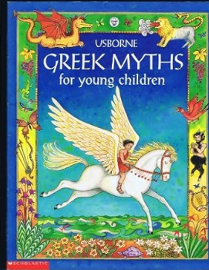  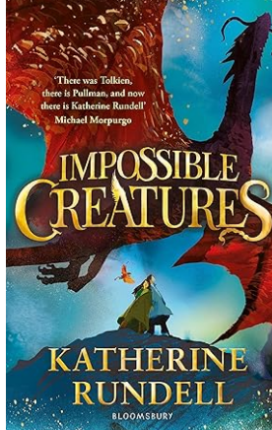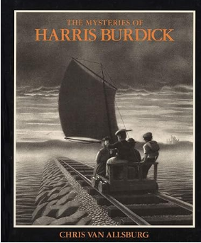 |  | - Compose and rehearse sentences orally (including dialogue), progressively building a varied and rich vocabulary and increasing the range of sentence structures.  - Plan their writing by identifying the audience for and purpose of the writing, selecting the appropriate form and using other similar writing as models for their own  - Note and develop initial ideas, drawing on reading and research where necessary  - Consider how authors have developed characters and settings.  - Draft and write by beginning to describe settings, characters and atmosphere and integrating dialogue to convey character and advance the action in narratives.  - Draft and write by beginning to select appropriate grammar and vocabulary, understanding how such choices can change and enhance meaning.  - Evaluate and edit by assessing the effectiveness of their own and others writing  - Edit by proposing changes to vocabulary, punctuation and grammar to enhance effects and clarify meaning  - Proof read for spelling and punctuation errors  - Perform their own compositions using appropriate intonation, volume and movement so that meaning is clear  - Draft and write by beginning to precis longer passages. |  |  | Standard English  synonyms  inverted commas  time adverbials/conjunctions  reporting clause  preposition  subordinate clause  main clause  rhetorical questions  emotive language  direct speech  reported speech  figurative language  possessive apostrophe  comma  informal  formal  modal verbs  relative clauses  organisational devices | tone  tension  suspense  mood  atmosphere  imagery  pathetic fallacy  opinion  hyphen  rhyming couplets  kenning  stanza  bracket  dash  parenthesis  lipogram  diamante  symbolism
Year 5 Spring

Year 5 Summer
Spelling | Handwriting |  | Punctuation | Grammar
Pupils should be taught to spell:  - Words with letter string ‘ough’  - Adverbials of time  - Adverbials of place  - Words with an ‘ear sound spelt ‘ere’  - Words from the spelling list: afterwards, amateur, ancient, amateur, ancient, bargain, muscle, queue, recognise, twelfth, identity, develop, harass  - Words with unstressed vowels in polysyllabic words  - Words with prefixes de- and re-  - Words with prefix over-  - Words with suffix -ful  - Words with suffix -ive  - Words with suffix -al | - Write legibly, fluently and with increasing speed by: choosing which shape of a letter to use when given choices, and deciding which letters to join; and choosing the writing implement best suited to the task. |  | - Use commas after fronted adverbials  - Use inverted commas and other punctuation to indicate direct speech  - Indicate possession by using the possessive apostrophe with plural nouns  - Use commas to clarify meaning or avoid ambiguity  - Use brackets, dashes or commas to indicate parenthesis  - Use further organisational and presentational devices to structure text and guide the reader e.g., headings, bullet points, underlining  - Use the colon to introduce a list and use semicolons within lists  - Use ellipsis for effect | - Use Standard English forms for verbs inflections instead of local forms e.g. we were not we was  - Use noun phrases expanded by the addition of modifying adjectives, nouns and preposition phrases  - Extend the range of sentences with more than one clause by using a wider range of conjunctions  - Understand how words are related by meaning as synonyms and antonyms, and use a thesaurus to such for suitable synonyms.  - Know that difference between vocabulary typical of informal speech and vocabulary appropriate for formal speech and writing.  - Use present perfect forms of verbs.  - Use devices to build cohesion with a paragraph e.g. then, after that, this  - Use relative clauses beginning who, which, where, when, whose, that, or an omitted relative pronoun  - Vary the position of subordinating clauses with intention and effect.  - Indicate degrees of possibility using adverbs (perhaps, surely) or modal verbs  - Use a range of verb tenses consistently and correctly.  - Link ideas across paragraphs using adverbials of time, place and number or tense choice
Text for the term |  | Composition |  |  | Terminology
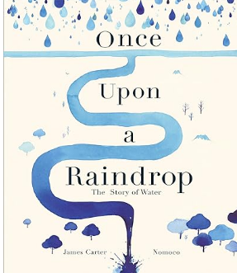  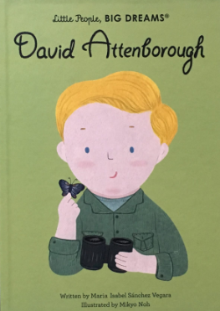 |  | - Compose and rehearse sentences orally (including dialogue), progressively building a varied and rich vocabulary and increasing the range of sentence structures.  - Plan their writing by identifying the audience for and purpose of the writing, selecting the appropriate form and using other similar writing as models for their own  - Note and develop initial ideas, drawing on reading and research where necessary  - Consider how authors have developed characters and settings.  - Draft and write by beginning to describe settings, characters and atmosphere and integrating dialogue to convey character and advance the action in narratives.  - Draft and write by beginning to select appropriate grammar and vocabulary, understanding how such choices can change and enhance meaning.  - Draft and write by beginning to precis longer passages.  - Evaluate and edit by assessing the effectiveness of their own and others writing  - Edit by proposing changes to vocabulary, punctuation and grammar to enhance effects and clarify meaning  - Proof read for spelling and punctuation errors  - Perform their own compositions using appropriate intonation, volume and movement so that meaning is clear |  |  | Standard English  synonyms  inverted commas  time adverbials/conjunctions  reporting clause  preposition  subordinate clause  main clause  rhetorical questions  emotive language  direct speech  reported speech  figurative language  possessive apostrophe  comma  informal  formal  modal verbs  relative clauses | organisational devices tone  tension  suspense  mood  atmosphere  imagery  pathetic fallacy  opinion  hyphen  rhyming couplets  kenning  stanza  bracket  dash  parenthesis  lipogram  diamante  symbolism

