Year 6 Autumn

Spelling |  | Handwriting | Punctuation |  | Grammar
Pupils should be taught to spell:  - Words that are ambitious synonyms  - Words that are homophones or near homophones  - Words ending in -ant and -ance.  - Words ending in ‘ent’ or ‘ence’  - Words with hyphens to join prefix ending in vowel to root word beginning with a vowel.  - Words with hyphens to avoid ambiguity  - Words ending in ‘able’  - Words ending in ‘ably’  - Word families based on common words showing how words are related in form and meaning  - Words with prefixes ‘mini’ and ‘micro’ to create diminutives. |  | - Write legibly, fluently and with increasing speed by: choosing which shape of a letter to use when given choices, and deciding which letters to join; and choosing the writing implement best suited to the task (Y5) | - Use commas to clarify meaning or avoid ambiguity.  - Use brackets, dashes or commas to indicate parenthesis.  - Use further organisational and presentational devices to structure text and guide the reader e.g., headings, bullet points, underlining  - Use inverted commas and other punctuation to indicate direct speech.  - Use the colon to introduce a list and use semicolons within lists.  - Use ellipsis for effect.  - Use a semicolon, colon and dash to mark the boundary between independent clauses. |  | - Indicate degrees of possibility using adverbs (perhaps, surely) or modal verbs.  - Use relative clauses beginning who, which, where, when, whose, that, or an omitted relative pronoun.  - Know the difference between vocabulary typical of informal speech and vocabulary appropriate for formal speech and writing.  - Know how words are related by meaning as synonyms and antonyms.  - Use structures typical of informal speech and structures appropriate of formal speech and writing.  - Ensure the consistent and correct use of tense throughout a piece of writing  - Ensure correct subject and verb agreement when using singular and plural  - Use passive voice to affect the presentation of information in a sentence.  - Use a range of clause structures, varying the positions of subordinating clauses with intention and effect, including subordinate clauses with no conjunction, e.g., -ing verbs, -ed verbs.
Text for the term | Composition |  |  | Terminology
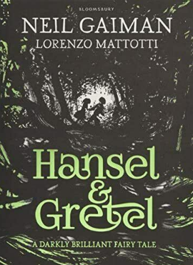  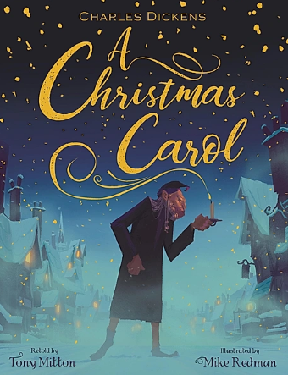 | - Compose and rehearse sentences orally (including dialogue), progressively building a varied and rich vocabulary and increasing the range of sentence structures.  - Plan their writing by identifying the audience for and purpose of the writing, selecting the appropriate form and using other similar writing as models for their own.  - Draft and write by selecting appropriate vocabulary and grammatical structures that reflect what the writing requires, understanding how such choices can change and enhance meaning.  - Draft and write by describing settings and characters to convey character and advance the action in narratives.  - Draft and write by using a wide range of devices to build cohesion within and across paragraphs.  - Proof-read for spelling and punctuation errors.  - Evaluate and edit by assessing the effectiveness of their own and others writing.  - Edit by proposing changes to vocabulary, punctuation and grammar to enhance effects and clarify meaning.  - Precising longer passages.  - Perform their own compositions using appropriate intonation, volume and movement so that meaning is clear. |  |  | Standard English  synonyms  reporting clause  subordinate clause  main clause  rhetorical questions  emotive language  direct speech  reported speech  figurative language  possessive apostrophe  informal  formal  modal verbs  relative clauses |  | organisational devices  tone  tension  suspense  mood  atmosphere  imagery  pathetic fallacy bracket  dash  parenthesis  lipogram  diamante  symbolism  onomatopoeia | opinion  hyphen  rhyming couplets  kenning  stanza  reverse poem  ellipsis  colon  semicolon  synonym  antonym  subjunctive forms  debate  oxymoron  personal/impersonal  hyperbole
Year 6 Spring
Spelling | Handwriting |  | Punctuation | Grammar
Pupils should be taught to spell:  - Adding suffixes to words ending in -fer  - Words with long ‘e’ sound spelt ‘ie’ or ‘ei’ after c  - Word families based on common words showing how words are related in form and meaning.  - Words from the spelling list: attached, available, average, competition, conscience, controversy, correspond, embarrass, especially, exaggerate  - Words ending in ‘cial’  - Words ending in ‘tial’  - Words with soft c spelt ‘ce.  - Word families based on common words showing how words are related in form and meaning  - Words from the spelling list: foreign, apparent, appreciate, persuade, individual, language, sufficient, determined, explanation, pronunciation | - Write legibly, fluently and with increasing speed by: choosing which shape of a letter to use when given choices, and deciding which letters to join; and choosing the writing implement best suited to the task. |  | - Use commas to clarify meaning or avoid ambiguity.  - Use brackets, dashes or commas to indicate parenthesis.  - Use further organisational and presentational devices to structure text and guide the reader e.g., headings, bullet points, underlining  - Use inverted commas and other punctuation to indicate direct speech.  - Use the colon to introduce a list and use semicolons within lists.  - Use ellipsis for effect.  - Use a semicolon, colon and dash to mark the boundary between independent clauses.  - Use hyphens to avoid ambiguity. | - Indicate degrees of possibility using adverbs (perhaps, surely) or modal verbs.  - Use relative clauses beginning who, which, where, when, whose, that, or an omitted relative pronoun.  - Know the difference between vocabulary typical of informal speech and vocabulary appropriate for formal speech and writing.  - Know how words are related by meaning as synonyms and antonyms.  - Use structures typical of informal speech and structures appropriate of formal speech and writing, or the use of subjunctive forms.  - Ensure the consistent and correct use of tense throughout a piece of writing  - Ensure correct subject and verb agreement when using singular and plural  - Use passive voice to affect the presentation of information in a sentence.  - Use a range of clause structures, varying the positions of subordinating clauses with intention and effect, including subordinate clauses with no conjunction, e.g., -ing verbs, -ed verbs.  - Link ideas across paragraphs using a wider range of cohesive devices such as, repetition of a word or phrase, grammatical connections e.g., using adverbials such as, on the other hand, and ellipsis.  - Select appropriate grammar and vocabulary, understanding how choices can change and enhance meaning.
Text for the term |  | Composition |  |  | Terminology
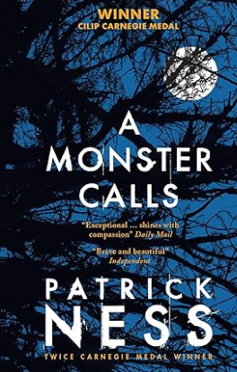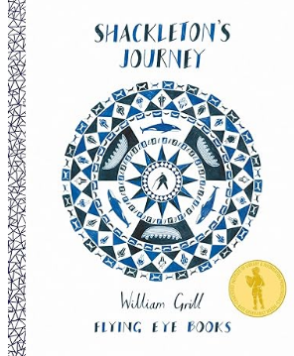  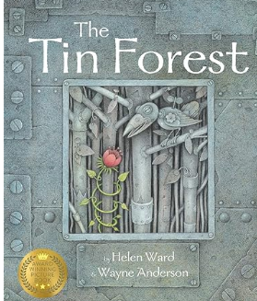 |  | - Compose and rehearse sentences orally (including dialogue), progressively building a varied and rich vocabulary and increasing the range of sentence structures.  - Plan their writing by identifying the audience for and purpose of the writing, selecting the appropriate form and using other similar writing as models for their own.  - Draft and write by selecting appropriate vocabulary and grammatical structures that reflect what the writing requires, understanding how such choices can change and enhance meaning.  - Draft and write by describing settings, characters and atmosphere and integrating dialogue to convey character and advance the action in narratives.  - Draft and write by using a wide range of devices to build cohesion within and across paragraphs.  - Proof-read for spelling and punctuation errors.  - Evaluate and edit by assessing the effectiveness of their own and others writing.  - Edit by proposing changes to vocabulary, punctuation and grammar to enhance effects and clarify meaning.  - Precising longer passages.  - Perform their own compositions using appropriate intonation, volume and movement so that meaning is clear. |  |  | Standard English  synonyms  reporting clause  subordinate clause  main clause  rhetorical questions  emotive language  direct speech  reported speech  figurative language  possessive apostrophe  informal  formal  modal verbs  relative clauses  organisational devices  tone  tension  suspense  mood  atmosphere  imagery  pathetic fallacy | opinion  hyphen  rhyming couplets  kenning  stanza  bracket  dash  parenthesis  lipogram  diamante  symbolism  onomatopoeia  reverse poem  ellipsis  colon  semicolon  synonym  antonym  subjunctive forms  debate  oxymoron  personal/impersonal  hyperbole
Year 6 Summer
Spelling | Handwriting | Punctuation |  | Grammar
- Word families based on common words showing how words are related in form and meaning  - Words that can be nouns and verbs  - Words with long ‘o’ sound spelt ‘ou’ or ‘ow’  - Words ending in -ible  - Words ending in -ibly  - Synonyms and antonyms | - Write legibly, fluently and with increasing speed by: choosing which shape of a letter to use when given choices, and deciding which letters to join; and choosing the writing implement best suited to the task. | - Use commas to clarify meaning or avoid ambiguity.  - Use brackets, dashes or commas to indicate parenthesis.  - Use further organisational and presentational devices to structure text and guide the reader e.g., headings, bullet points, underlining  - Use inverted commas and other punctuation to indicate direct speech.  - Use the colon to introduce a list and use semicolons within lists.  - Use ellipsis for effect.  - Use a semicolon, colon and dash to mark the boundary between independent clauses.  - Use hyphens to avoid ambiguity. |  | - Indicate degrees of possibility using adverbs (perhaps, surely) or modal verbs.  - Use relative clauses beginning who, which, where, when, whose, that, or an omitted relative pronoun.  - Know the difference between vocabulary typical of informal speech and vocabulary appropriate for formal speech and writing.  - Know how words are related by meaning as synonyms and antonyms.  - Use structures typical of informal speech and structures appropriate of formal speech and writing, or the use of subjunctive forms.  - Ensure the consistent and correct use of tense throughout a piece of writing  - Ensure correct subject and verb agreement when using singular and plural  - Use passive voice to affect the presentation of information in a sentence.  - Use a range of clause structures, varying the positions of subordinating clauses with intention and effect, including subordinate clauses with no conjunction, e.g., -ing verbs, -ed verbs.  - Link ideas across paragraphs using a wider range of cohesive devices such as, repetition of a word or phrase, grammatical connections e.g., using adverbials such as, on the other hand, and ellipsis.  - Select appropriate grammar and vocabulary, understanding how choices can change and enhance meaning.  - Use the subjunctive form, such as, ‘if I were’ or ‘were they to come’.
Text for the term |  |  | Composition |  | Terminology
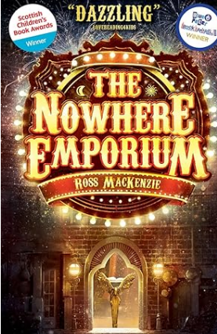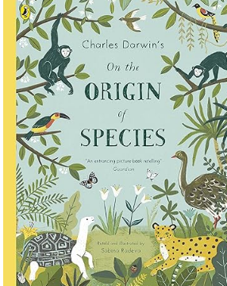 |  |  | - Compose and rehearse sentences orally (including dialogue), progressively building a varied and rich vocabulary and increasing the range of sentence structures.  - Plan their writing by identifying the audience for and purpose of the writing, selecting the appropriate form and using other similar writing as models for their own.  - Draft and write by selecting appropriate vocabulary and grammatical structures that reflect what the writing requires, understanding how such choices can change and enhance meaning.  - Draft and write by describing settings, characters and atmosphere and integrating dialogue to convey character and advance the action in narratives.  - Draft and write by using a wide range of devices to build cohesion within and across paragraphs.  - Proof-read for spelling and punctuation errors.  - Evaluate and edit by assessing the effectiveness of their own and others writing.  - Edit by proposing changes to vocabulary, punctuation and grammar to enhance effects and clarify meaning.  - Precising longer passages.  - Perform their own compositions using appropriate intonation, volume and movement so that meaning is clear. |  | Standard English  synonyms  reporting clause  subordinate clause  main clause  rhetorical questions  emotive language  direct speech  reported speech  figurative language  possessive apostrophe  informal  formal  modal verbs  relative clauses  organisational devices  tone  tension  suspense  mood  atmosphere  imagery  pathetic fallacy | opinion  hyphen  rhyming couplets  kenning  stanza  bracket  dash  parenthesis  lipogram  diamante  symbolism  onomatopoeia  reverse poem  ellipsis  colon  semicolon  synonym  antonym  subjunctive forms  debate  oxymoron  personal/impersonal  hyperbole

