

Marking and Feedback Policy

Approval confirmed:

Designation | Name | Date | Signature
Assessment lead: | Mr Pete Hales
Curriculum lead: | Mrs Carly Tonks

Monitoring and Evaluation
Original implementation date: | October 2021
Review frequency: | Annual
Date of next Review: | September 2026
Review delegated to:

Document Version control

Version | Changes made | Date
1.0 | Initial set up of school policy | October 2021

AIMS
At Willow Primary Academy we adopt the definition by Black and Wiliam (2009) where assessment is formative:

to the extent that evidence about student achievement is elicited, interpreted, and used by teachers, learners, or their peers, to make decisions about the next steps in instruction that are likely to be better, or better founded, than the decisions they would have taken in the absence of the evidence that was elicited

We therefore feedback to children through verbal and written form against the learning objectives and success criteria (where appropriate) to indicate their achievement, progress and next steps. Pupils will know what is expected of them when completing tasks as the teacher will share the Learning Point (LP) and success criteria with them. Focussed feedback should take place predominantly during the lesson, as we believe that formative assessment holds critical value in impacting on pupil’s future learning by moving their learning forward.

Whilst the DfE’s independent report acknowledges that “effective marking is an essential part of the education process”, it states in its summary that “at its heart, [marking] is an interaction between teacher and pupil: a way of acknowledging pupils’ work, checking the outcomes and making decisions about what teachers and pupils need to do next, with the primary aim of driving pupil progress”. There is extensive overlap between that statement and our definition of formative assessment. Therefore, we believe marking is one strategy within our overall approach to formative assessment.

Their summary recommendation is that “all marking should be meaningful, manageable and motivating. This should be the perspective adopted by all engaged in education, from classroom teachers to the Department for Education (DfE).”

Purpose of Marking and feedback (formative assessment)
- Indicate whether the child has achieved the learning point and/or success criteria and whether this was achieved independently or with support.
- Recognise, encourage and reward children’s effort and progress.
- Clearly inform children about strengths and successes in their work and set areas for development.
- Focus teachers’ attention to areas of learning where groups or individuals need further guidance and inform future planning.
- Respond to a child’s learning needs and ensure pupils address misunderstandings quickly and move on to next steps in their learning.
- Inform teachers of pupil progress in order to update school tracking systems.

Model of formative assessment
In implementing effective classroom formative assessment, we conceptualise formative assessment as the result of crossing three processes (where the pupil is going, where the pupil is right now and how to get there) with three types of agents in the classroom (teacher, peer, pupil) Leahy, Lyon, Thompson and Wiliam (2005):

 | Where the pupil is going | Where the pupil is now | How to get there
Teacher | Clarifying, sharing, and understanding learning points and success criteria | Engineering effective discussions, tasks, and activities that elicit evidence of learning. | Providing feedback that moves learning forward.
Peer |  | Activating students as learning resources for one another
Pupil |  | Activating students as owners of their own learning

Within this model, the core of assessment for learning is ‘responsive teaching’, the teacher’s processes, which can be described as using evidence of achievement to adapt what happens in classrooms to meet pupils’ needs.

Structure of feedback
- Teachers promote effective discussions to elicit learning. In order, to teach well, we have to find out what students already know. The best way to find out what pupils are thinking about is by talking to them through relatively unstructured dialogue, guided by the teacher’s expertise.
- The personal relationship between pupil and teacher, trust in particular, is crucial for effective feedback to take place.
- If feedback is given by teacher, another pupil or themselves, the pupil must be given time to act on that feedback (impacting on their future learning)
- Teachers use their professional judgement to decide when feedback should be given (frequently at the start of a lesson, as a whole class, when feeding back about learning from a previous lesson)
- Feedback from a previous lesson is also likely to be frequently given between lessons in a short, focused ‘post-teach/pre-teach’ session for specific pupils
- During lessons, teachers use their professional judgement to decide when live feedback should be given on a minute-by-minute basis
- Often, pupil’s next steps are the next lesson and requires no additional feedback
- Where the majority of pupils require similar feedback, feedback will be given as a whole class
- Where there is a wide range of feedback required to be given, the teacher will use their professional judgement as to how best to give meaningful feedback. For example, they may choose to:
  - Pick out and give all pupils a key element of the feedback as a whole class as it may still hold value for all pupils (e.g. deepening understanding)
  - Give all pupils a key element of the feedback in a whole class and then scaffold other pupils’ feedback through guided or 1:1 support later during the lesson
  - Give pupils a variety of feedback techniques at the same time which may include feedback in books, feedback on iPads, feedback from the teacher & other adults etc
- Teachers will use their professional judgement on the frequency and depth of feedback to give. They will be guided by the phrase ‘quality not quantity’
- Teachers can write comments in exercise books (marking) as a feedback technique but they should only do so when they deem it the most effective way of impacting on pupil’s future learning whilst being meaningful, manageable and motivating
- Written feedback should be legible, in line with school handwriting policy and easy to respond to focusing on achievements and next steps in the learning.
- Children’s achievements need to be celebrated in order to motivate and engage; however, we want our pupils to feel good about themselves because of their confidence in their ability to reach their goals, not because others tell them they are wonderful.

Feedback strategies
- Verbal feedback
- Teacher / Learning Partner assessment
- Self-assessment
- Peer assessment
1. Verbal feedback
Verbal feedback and constructive dialogue should happen regularly. It should be suitable to the individual needs of the children. This can be done as part of a whole class discussion or through dialogue with an individual or small group. If verbal feedback is given, then this should be recorded in the books using the code ‘VF’.

2. Teacher/ Learning Partner assessment
The LP and success criteria (where appropriate) should be shared with the children during the lesson, so they know what is expected of them and what they need to do to achieve well. The LP / success criteria slip should be stuck into the relevant book when appropriate. The success criteria should be adapted to suit the needs of individual children and this should be used when marking work and providing feedback.

In all books, the LP should be marked with the level of support the child required to complete the task using H, or M. H = high level of support, M = moderate level of support. The learning point and/or success criteria will also be highlighted to show overall achievement. Parts of the children’s work should also be highlighted in green to show which parts show evidence of the key learning. Pink highlighting may be used to show it’s not achieved yet for some pupils and identify points to edit.

3. Self-assessment
When students are owners of their own learning, all the other strategies fall into place. Wiliam, Leahy (2015)

A study by Barkat (2014) identified key factors in students increasing ownership of their own learning:

- Setting learning activities in the context of personal goals (relates to learning points and success criteria)
- Connecting effort investment to success (relates to providing feedback that moves learning forward)
- Engaging pupils in the planning of the work

This third factor involves helping pupils think about their thinking (metacognition). At Willow Primary, in the context of learning, we take this as meaning a pupil is able to ‘self-regulate their learning’, which involves managing emotions as well as metacognition.

Once pupils have begun to self-regulate their learning, they are on a path to becoming owners of their own learning.

All self-assessment should be completed in purple pen.

In KS1, pupils should be taught to self-assess in a meaningful way against the success criteria. By the end of Year 2, children should be placing a tick next to the success criteria fairly independently. Self-assessment should occur regularly by the end of KS1.

By the end of KS2, pupils should be self-assessing regularly and at a critical time to enable progress. They should also be encouraged to identify their own next step, especially in upper KS2, and be able to write this in response to their work.

Self-assessment should be modelled by the teacher and moderated, using a light touch mark to either agree or alter the assessment. Children should be praised for good, constructive and honest self-assessment verbally.

- Peer assessment
Engaging students in assessing the work of their peers is not just a labour-saving device for teachers. Implemented properly, it can substantially increase student achievement, both for those who get help from their peers, and peers who provide the help. Wiliam, Leahy (2015).

At Willow Primary Academy, peer assessment will take place through discussion of work. All peer assessment should be completed in purple pen by the owner of the work.

In KS1, pupils should be taught to peer assess in a meaningful way against the success criteria. By the end of KS2, pupils will peer assess when appropriate. Again, all peer assessment should be moderated by the teacher, using a light touch mark to either agree or alter the assessment.
Peer assessment should follow the same procedure as self-assessment.

Scaffolding feedback in English exercise books
- Teachers may leave work completely ‘unmarked’ to give pupils the opportunity to proof read, edit or move on without scaffolding feedback
- Teachers use their professional judgement to decide on the frequency and depth of scaffolding feedback
- Teachers may leave a code letter/symbol in the margin of a line indicating a slip or error. This scaffolding of feedback helps pupils with identification in proof reading/editing whilst leaving the pupil to work out the position of the slip or error. This will be in green pen in their books.
- Teachers may wiggly underline words/phrases or circles for omitted punctuation in writing to indicate a slip or error. This scaffolding of feedback helps pupils with the position of the slip or error whilst leaving the pupil to focus on identification. This will be in green pen in their books.
- Teachers may code and underline where required to further scaffold feedback for less able pupils and may highlight areas for attention in pink if required.
- All scaffolding of feedback can occur during the lesson, in verbal or written form, after the lesson in written form or in ‘keep up’ sessions

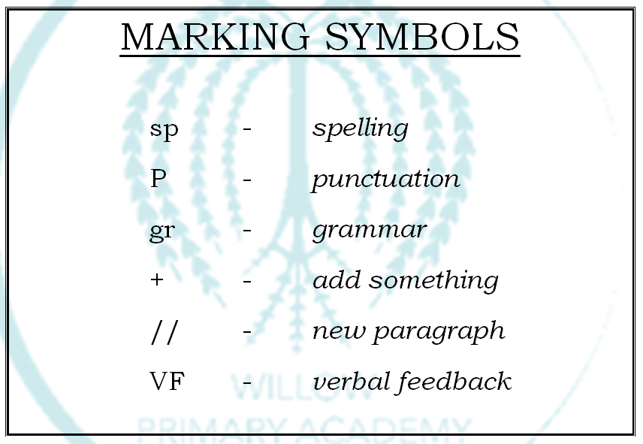

Scaffolding feedback in Maths exercise books
- Teachers may tick/dot/cross in books which scaffolds where the pupil has made slips (dot) or errors (cross). It is for the pupils to then go and attempt to fix these, where deemed impactful by the teacher. This will be in green pen in their books or together as a class on mini whiteboards or form the basis of the next lesson.
- Teachers use their professional judgement to decide on the frequency and depth of scaffolding feedback
- Teachers may choose to do none of the above when they have identified through their formative assessments/examination of exercise books what the next steps are and then feedback to the pupils in the next lesson.
- Most mistakes should be identified and addressed during the lesson through responsive and adaptive teaching
- H, M I code used to show child’s level of achievement.
- Next steps should be kept brief, for example:

H – 3333333

Sp - square

Scaffolding feedback in other exercise books
- Using their professional judgement, teachers may sometimes choose to use the same scaffolding of feedback techniques, as described for English above, when pupils have undertaken a substantial writing task (e.g. Writing a diary entry about ‘life as an Egyptian’).
- Teachers will feedback to pupils to impact on future learning. This will usually take place at the start of the next lesson, although the next lesson is not the next steps (which is often the case in other subjects). This could be done through a low stakes quiz or similar.
- Spelling of subject specific vocabulary should be addressed in the same way as in English books.

